1)Create one vpc in N.virginia region.

* First you have to Login to aws account.
* Next go to the n.virginia region.
* Go to the VPC and click on create Vpc.
* You have to give name and ipv4 cidr range.
* Next click on create Vpc

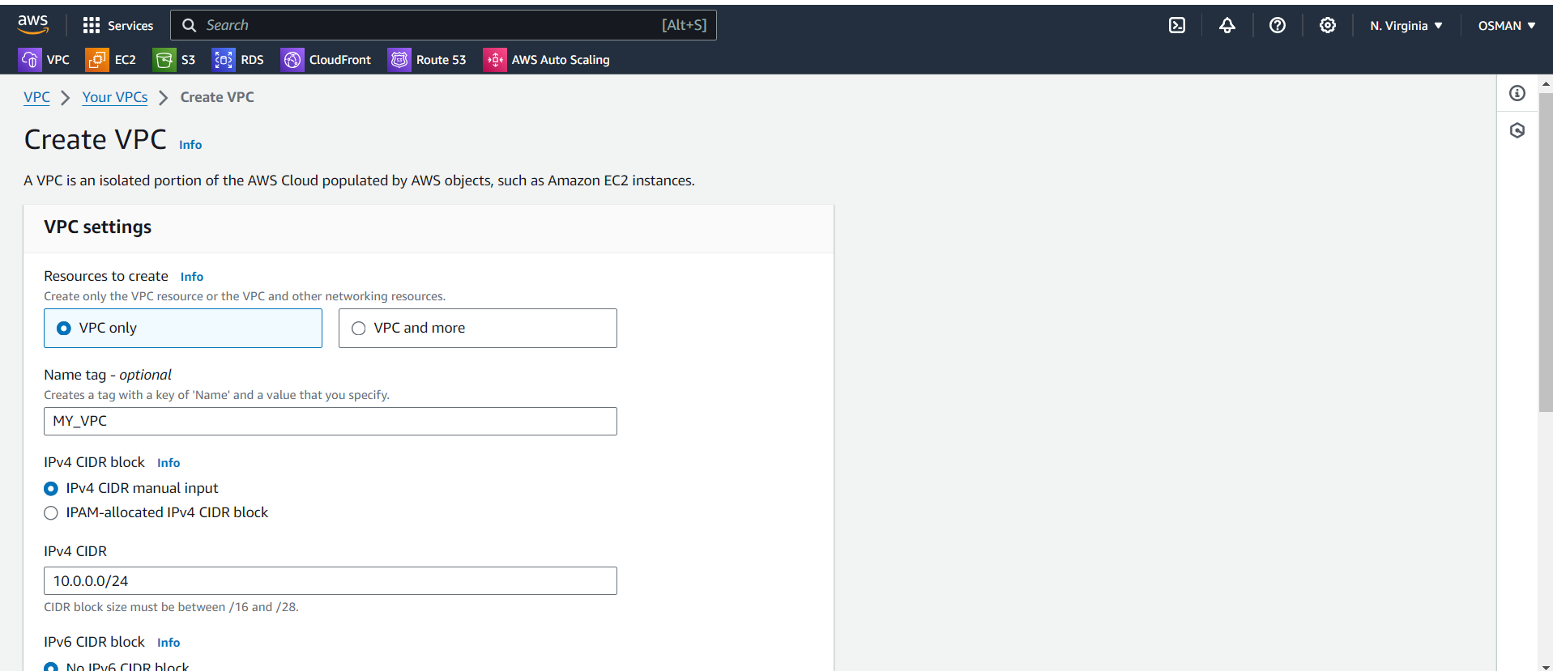

Your Vpc is created.

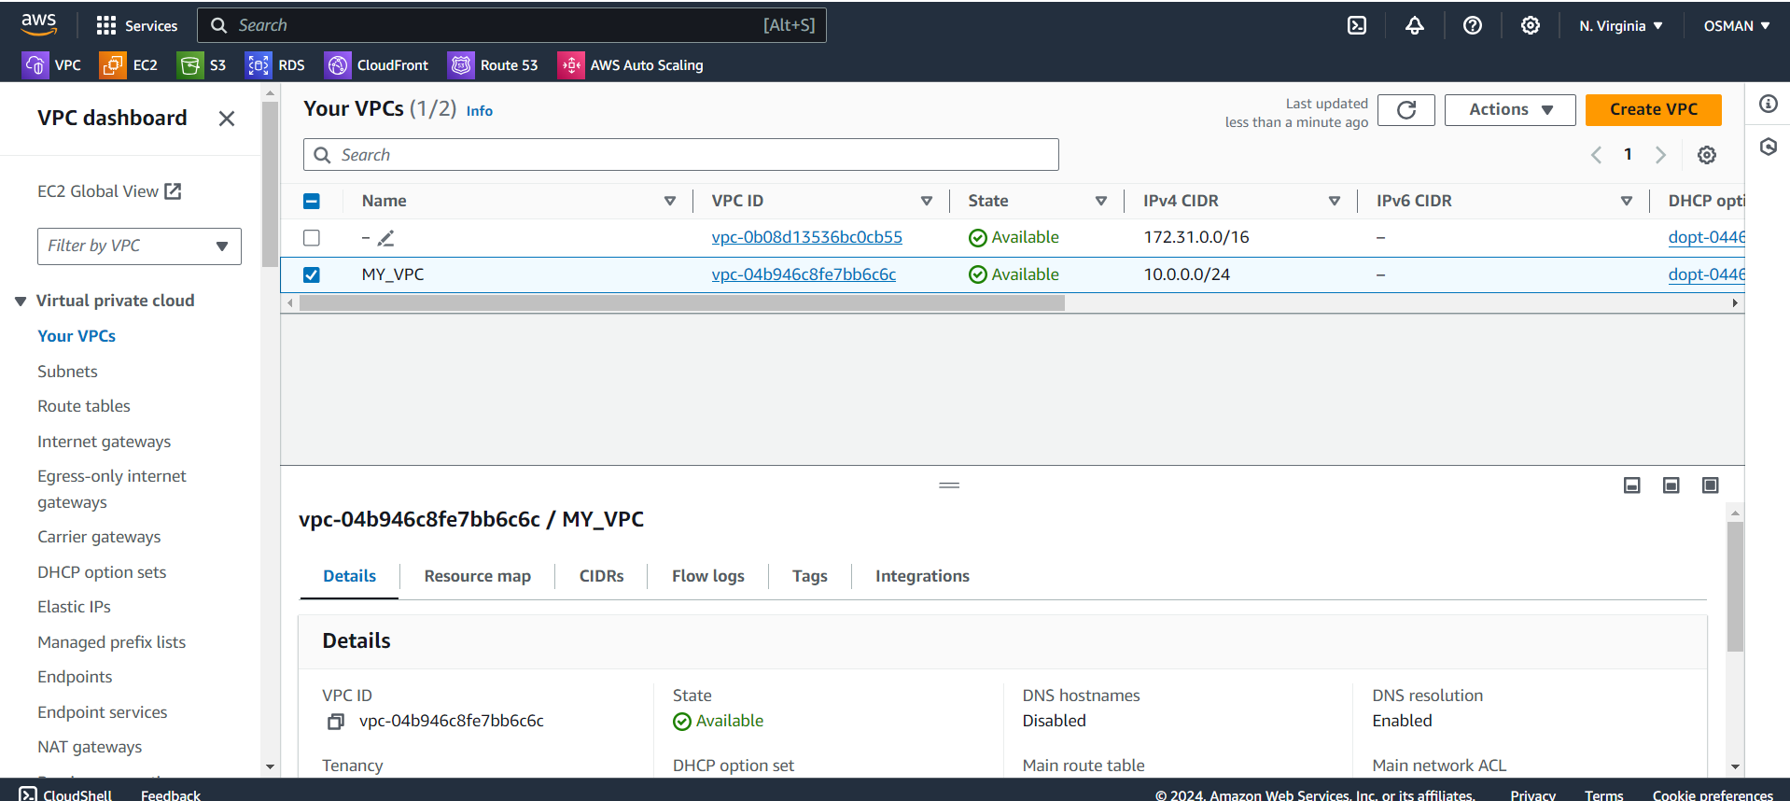

2) Create two subnets. One Public subnet and one private subnet.

* Click on subnets and create subnet.

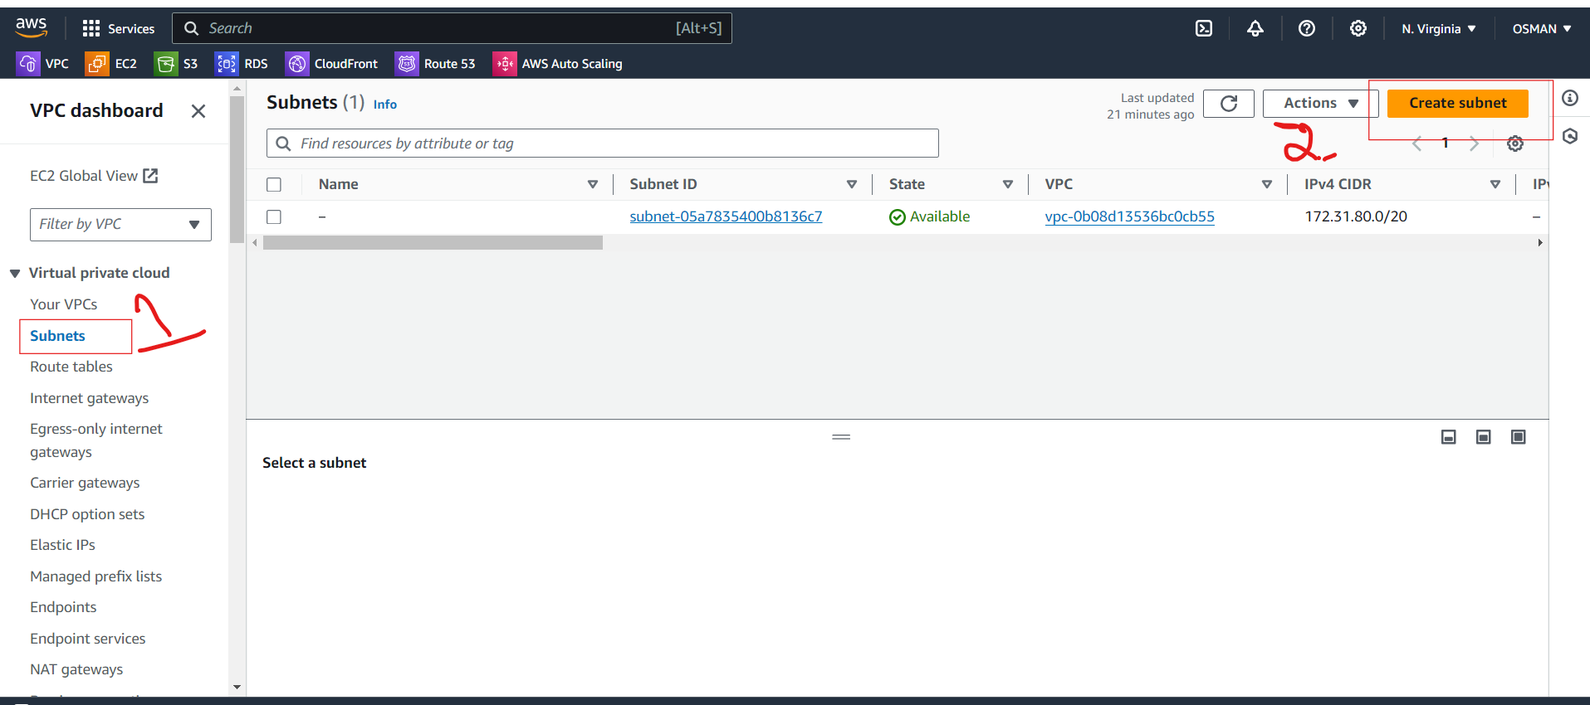

* You see the below interface.
* You need to select the VPC

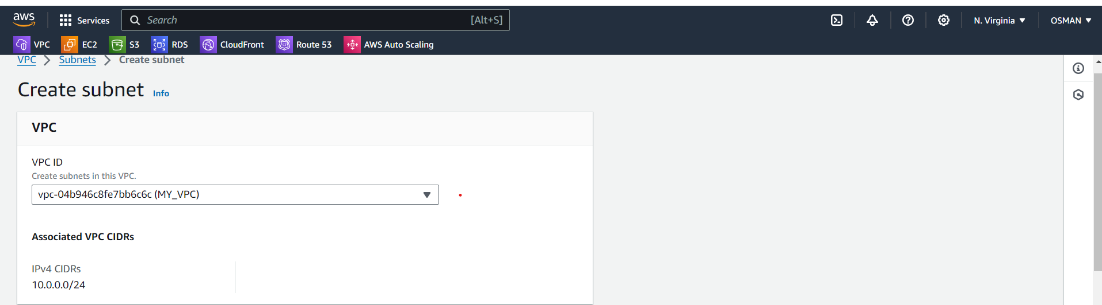

* Give name for subnet.
* Select Availability Zone.
* Give Ipv4 subnet cidr block.
* Click on create subnet.

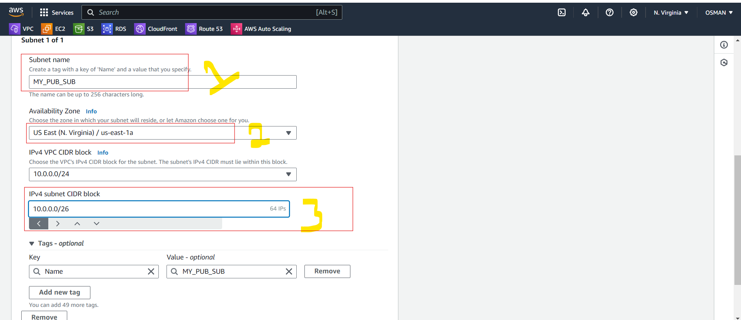

* Now I am crating the Pvt subnet.
* Follow the above steps what we did in pub-sub.
* You can observer the pvt-sub cidr range.

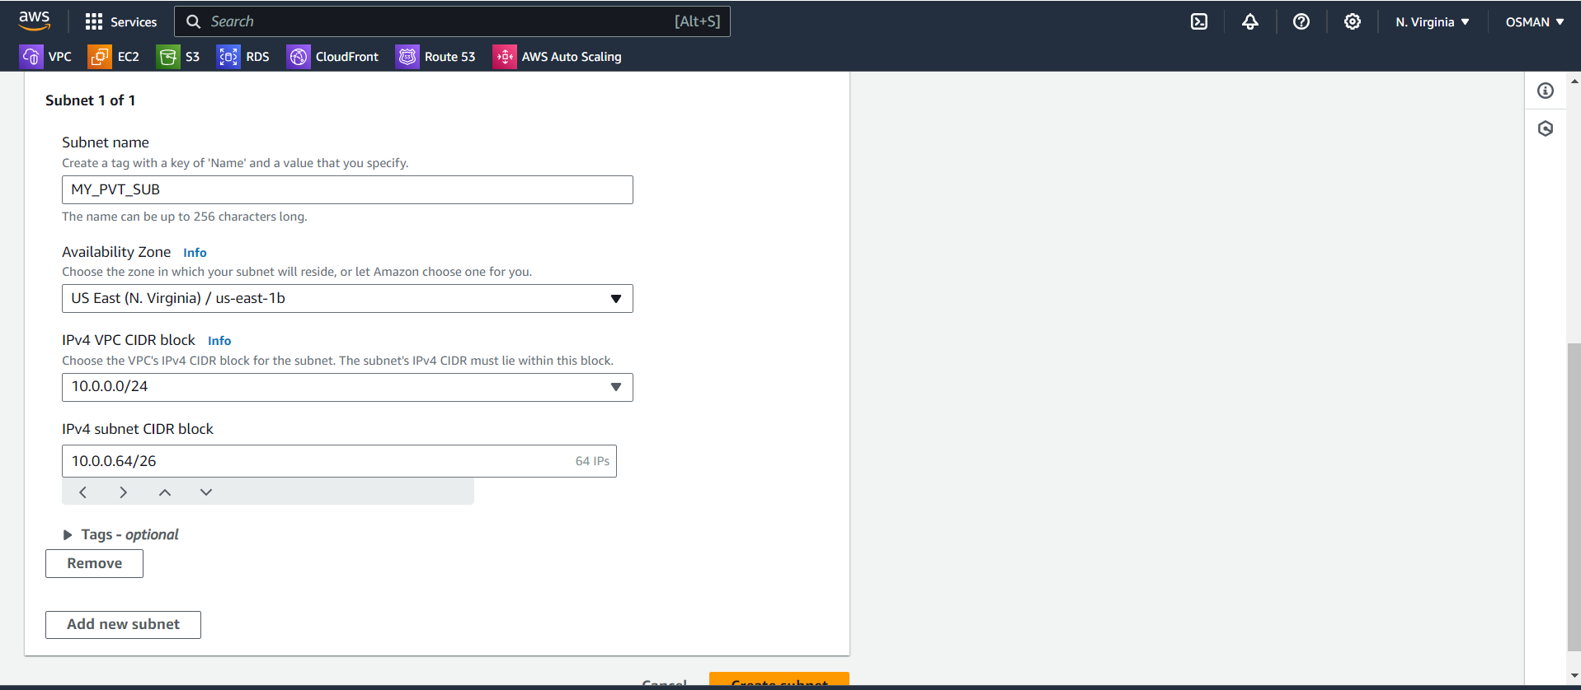

Now you will see below my Pub-sub and Pvt-sub.

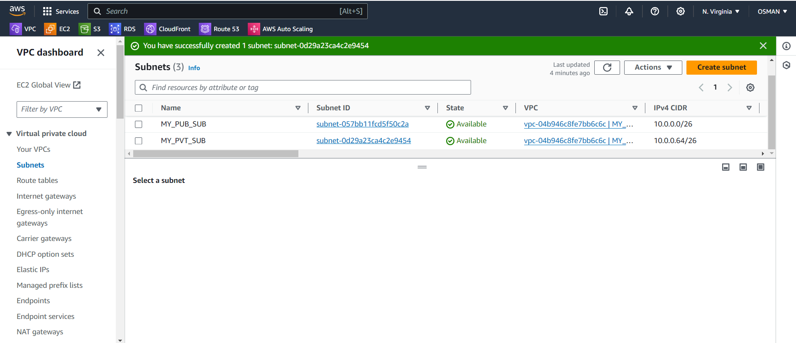

3) Provide the IGW to the vpc.

* Now I want attach internet gate-way to the VPC.
* First you need to create IGW.
* Click on internet gateways.
* You see one igw already attached to default VPC.
* Now click on create internet gateway.

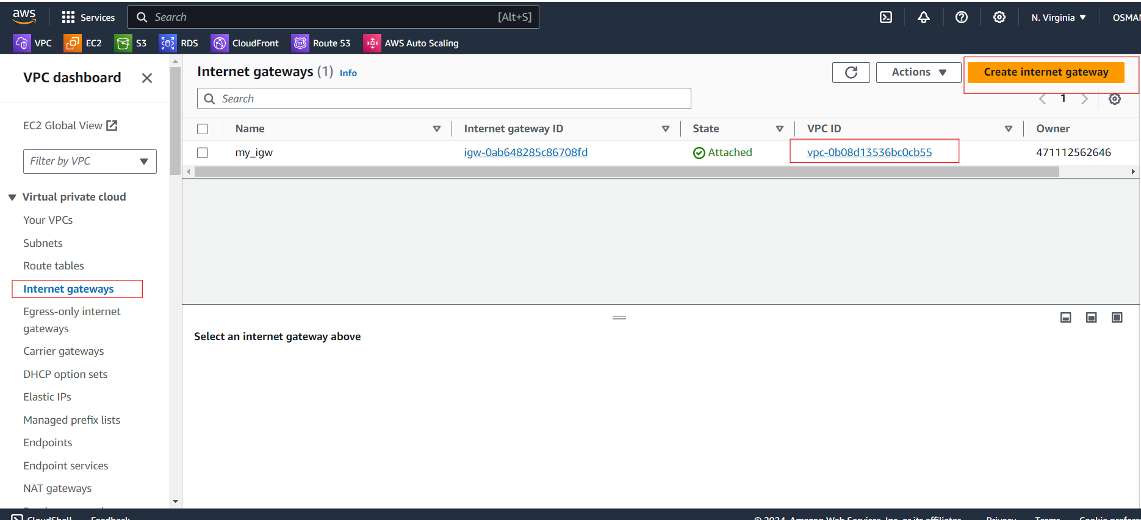

Give name and click on create IGW.

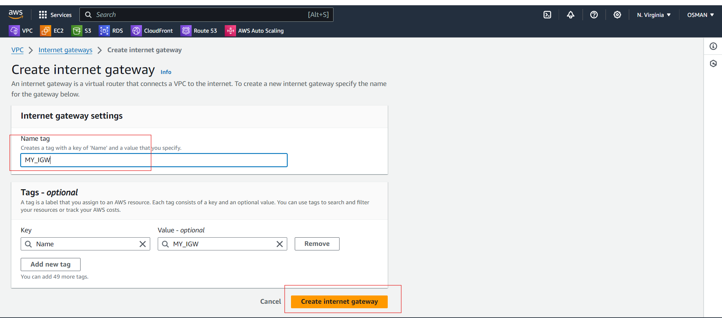

Here internet gateway is detached mode.

Click on checkbox and go to actions.

Click on attach VPC.

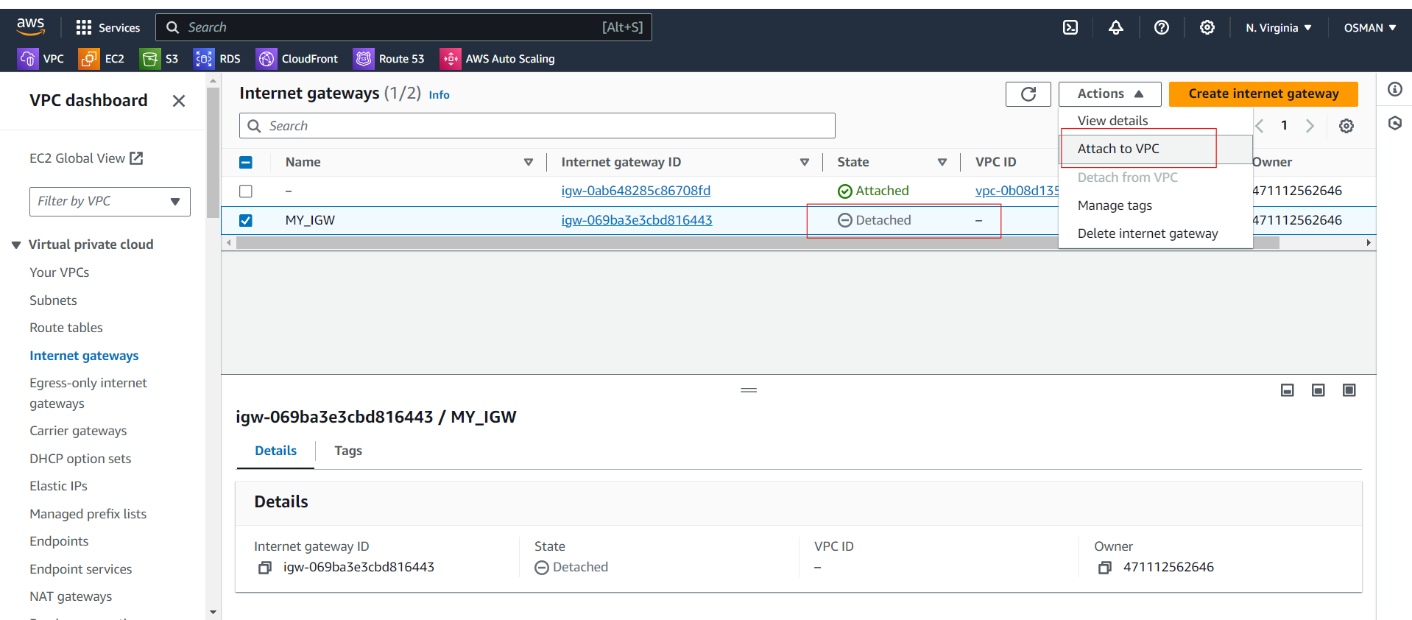

Just select VPC and attach internet gateway.

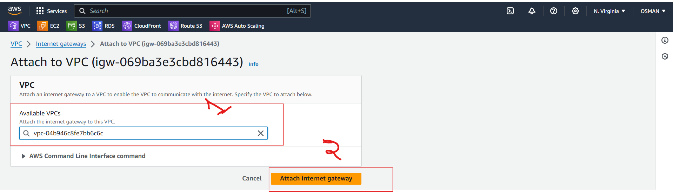

Now IGW gateway is attached to MY_VPC

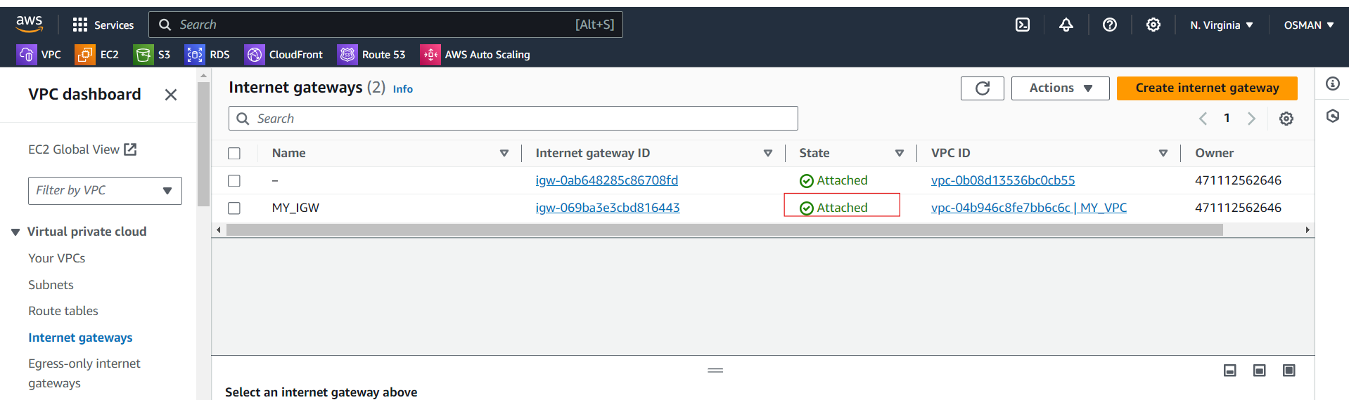

Task 3 completed.

4) Create One public RT and one private RT.

* Click on Route tables and create route table.

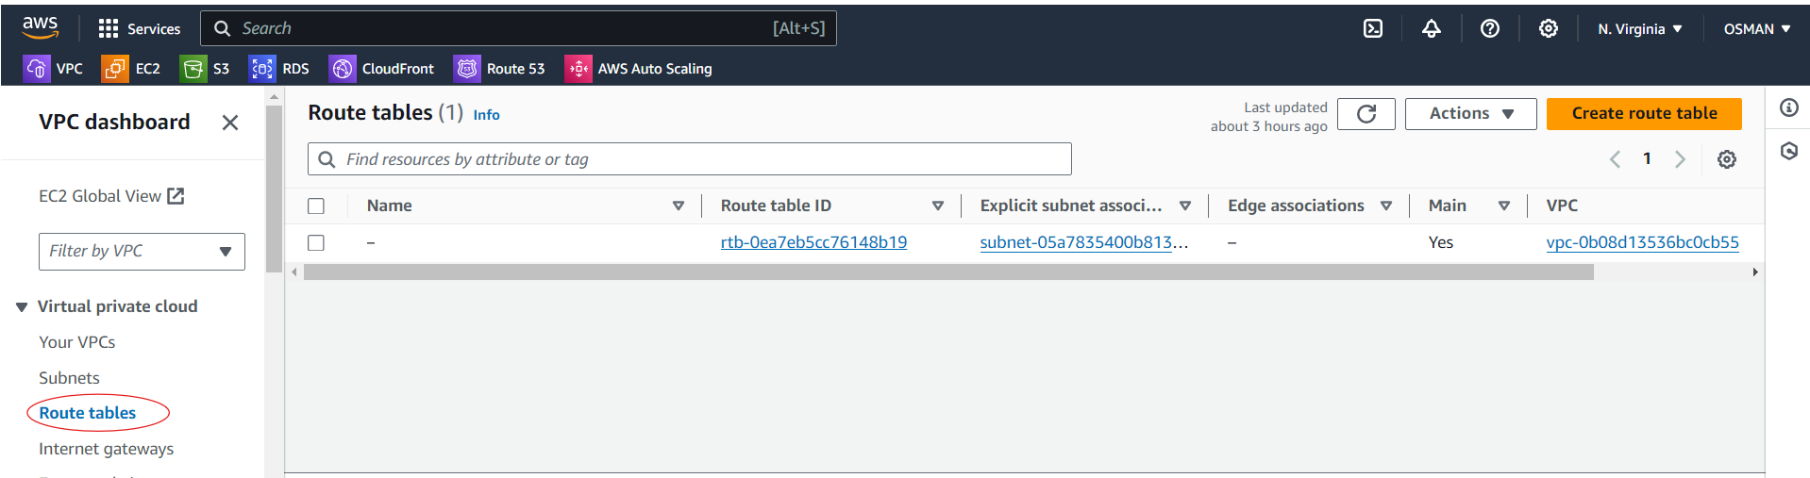

Give name, select VPC, and click on create route table.

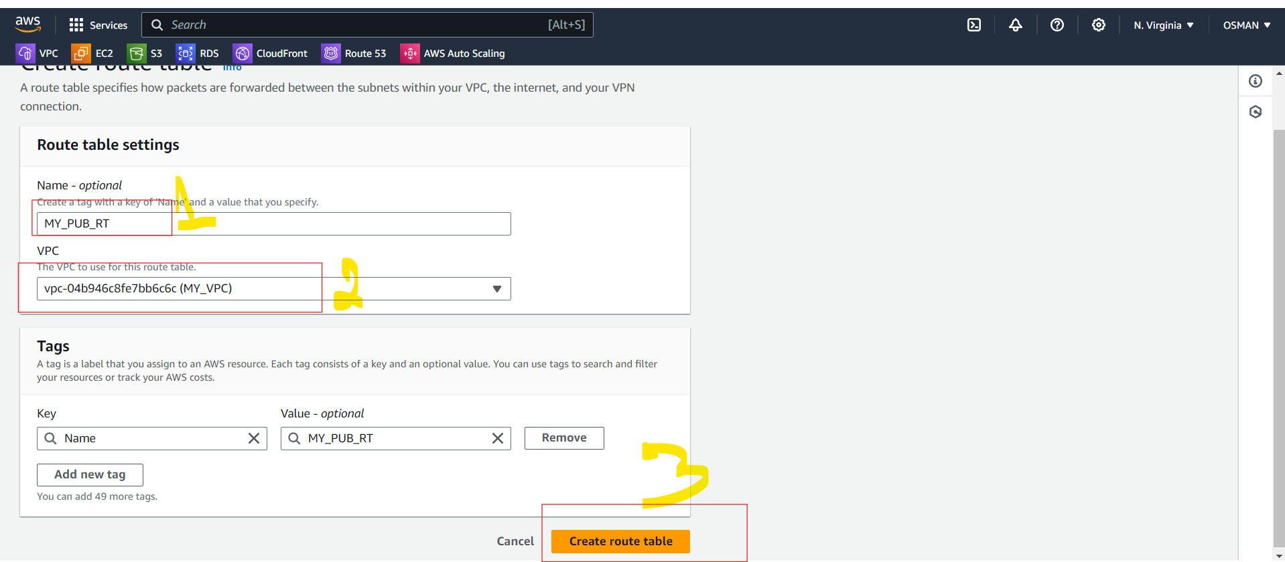

Now create private route table.

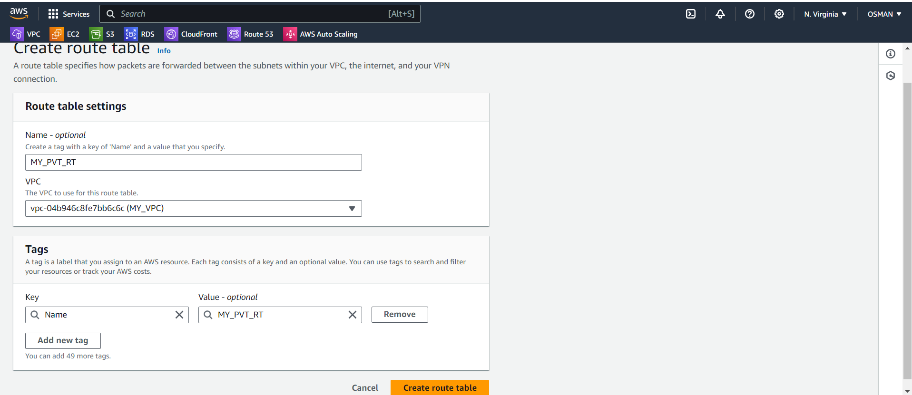

The below you can see the Two Route Tables.

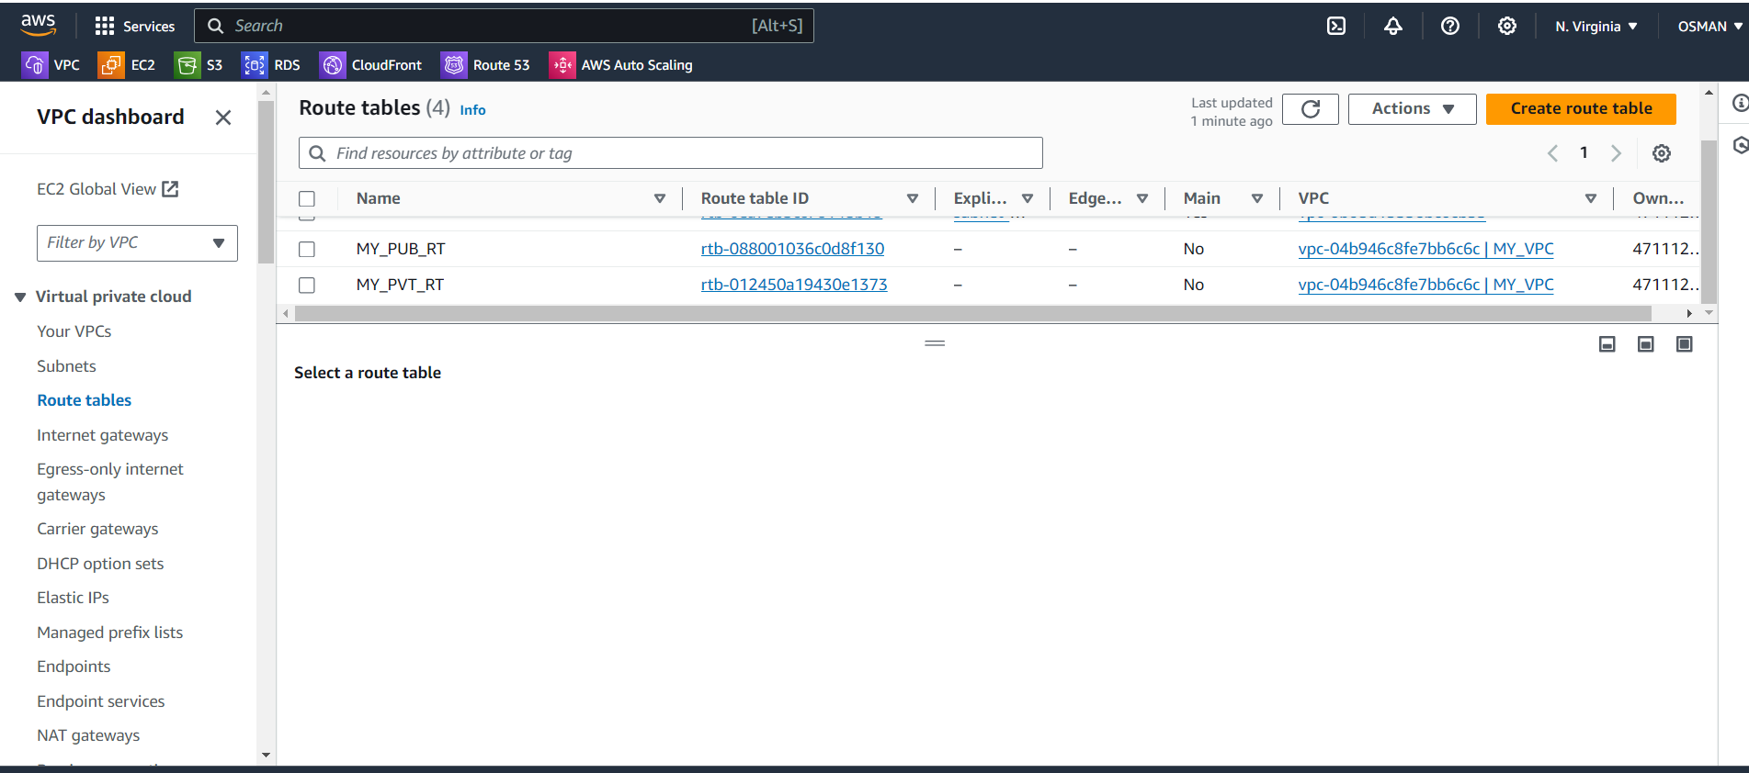

Task 4 completed.

#################

5) Deploy NAT gateway on public subnet and attach the NAT gateway to private subnet.

* Scroll down left you will see the option is NAT gateways and just click on that.
* Click on create NAT gateway.

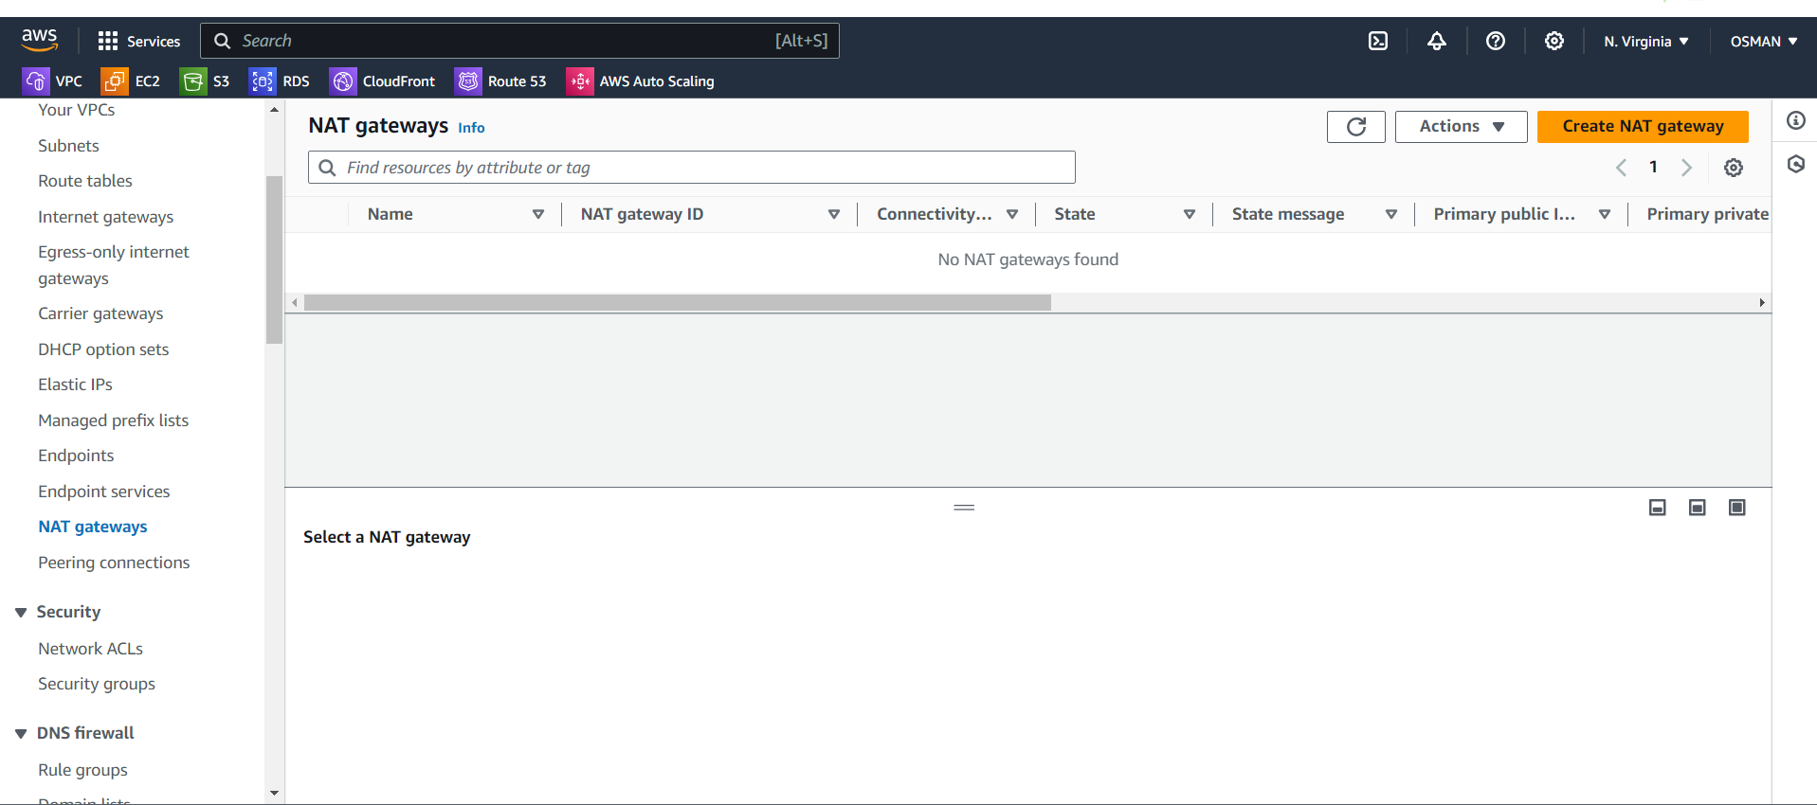

* Here below you give name –
* Always select public subnet.
* Connectivity type is public.
* Click on allocate elastic ip – it will create automatically one elastic ip.
* Click on create NGW.

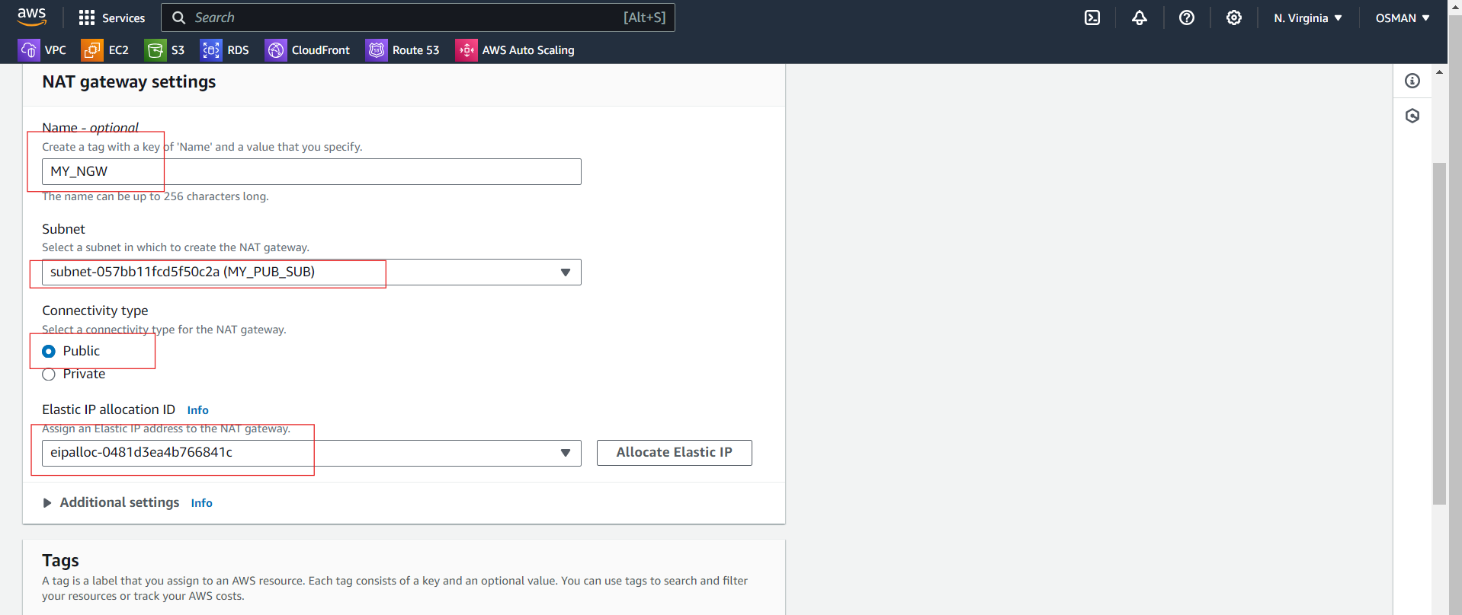

Now your NGW created wait for still status is available.

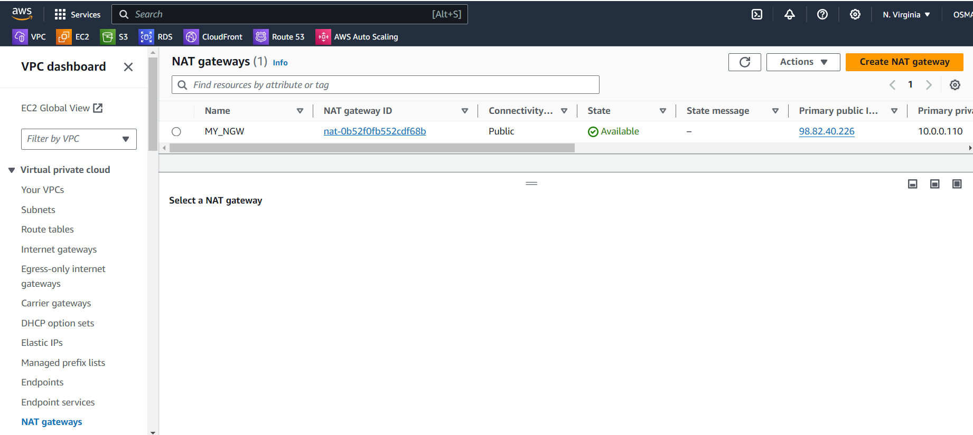

* Now we have to do NGW attach to PVT.
* To do that Go to the PVT and attach internet gateway.
* Click on check box of PVT_RT.
* Click on routes.
* Click on Edit routes.

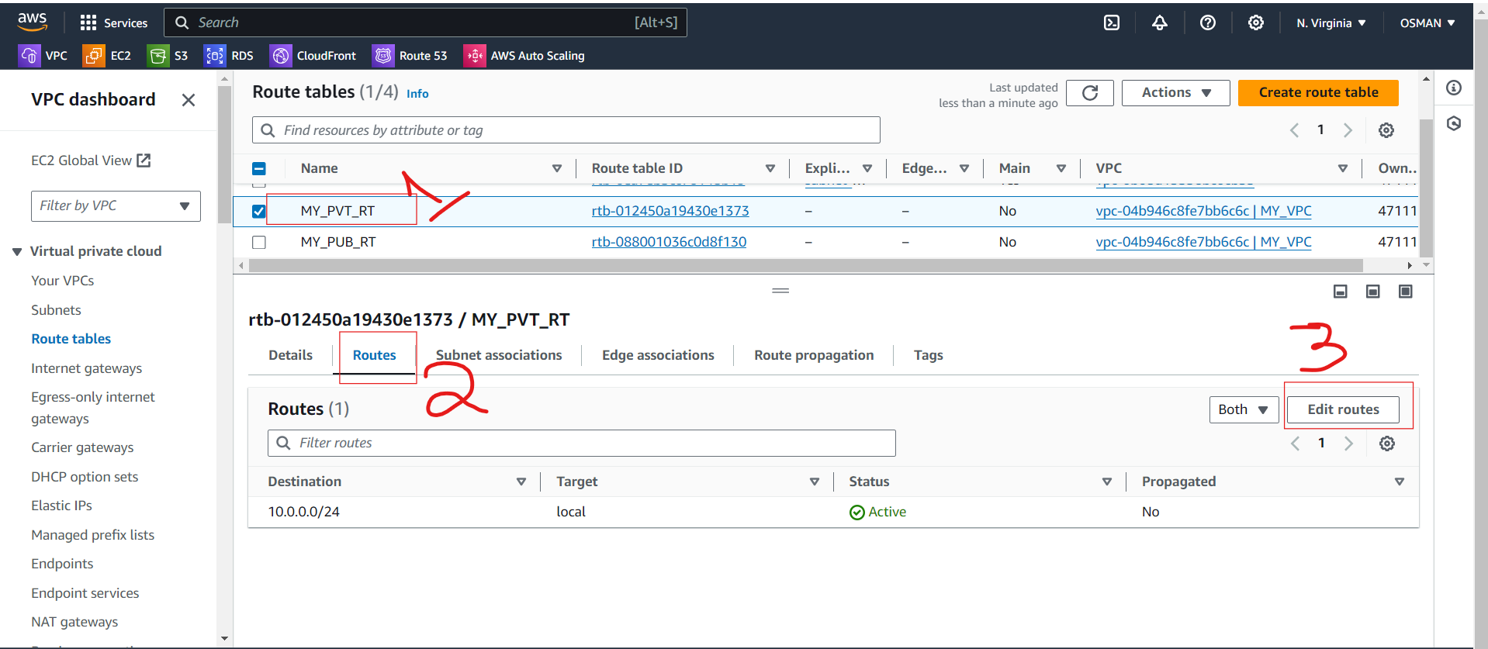

* Then you will see the below interface.
* First click on add rule and give destination.
* In Target you have select NAT Gateway and below should select id.
* Click on save changes.

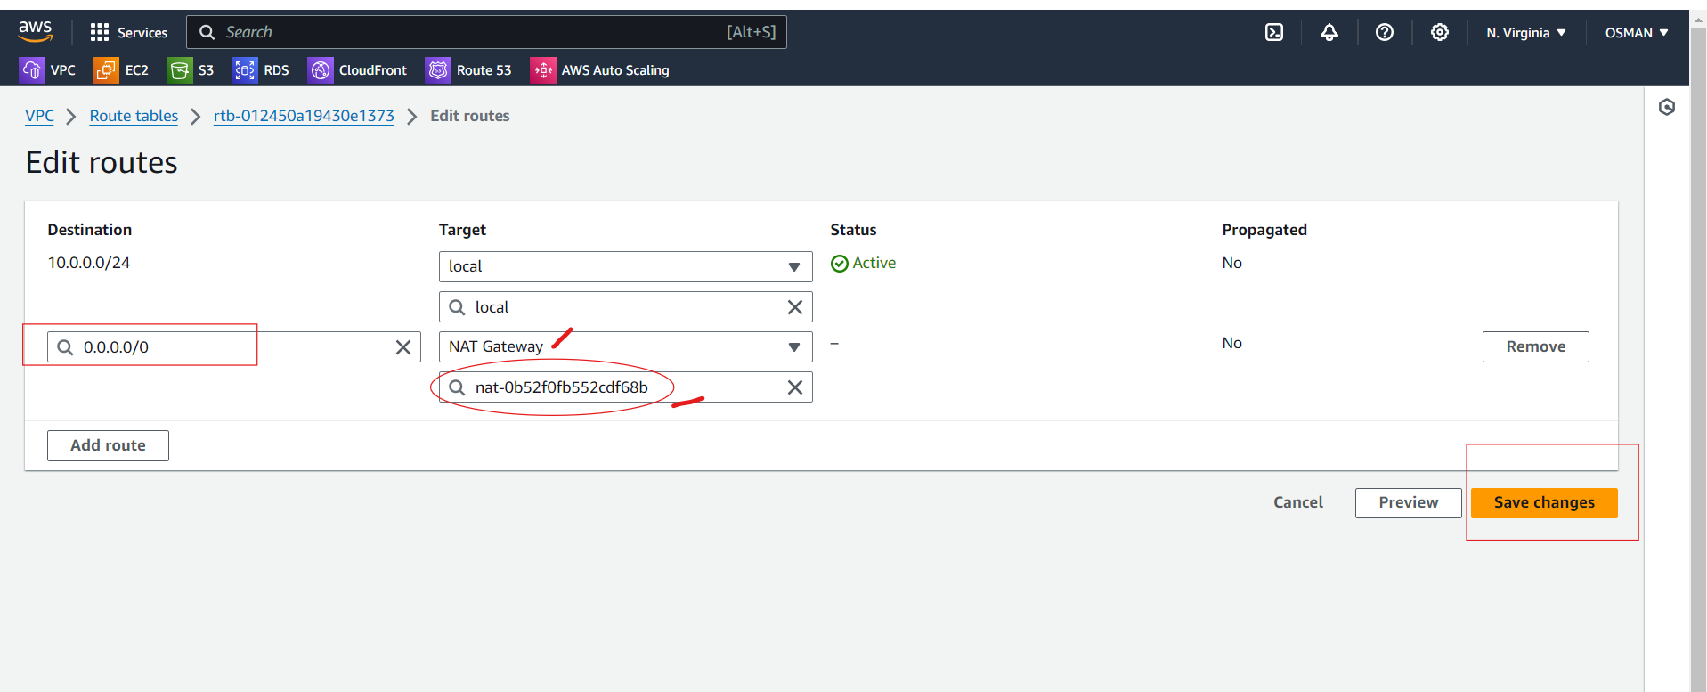

6) Create Two instances, one in public subnet and one in private subnet.

* Now I want to create Two instances one in public subnet and one in private subnet.
* First go to the instances and click on crate ec2 instance.

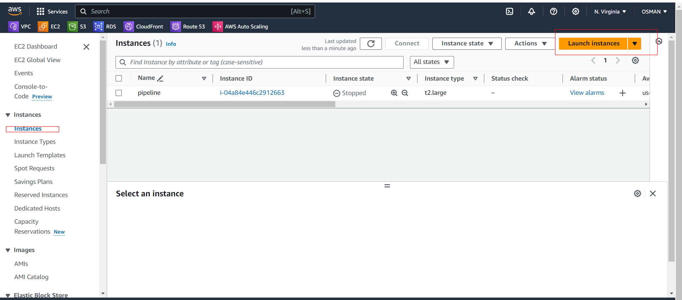

* Give name and select AMI.

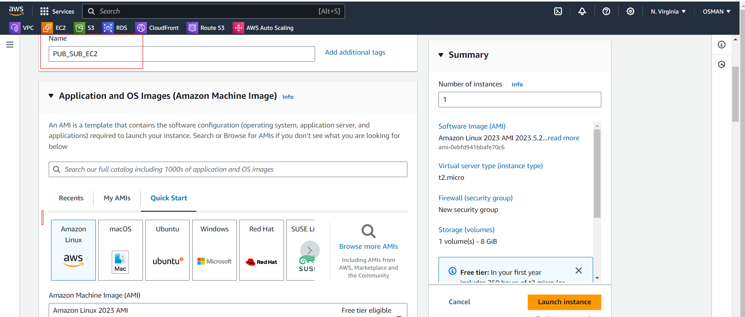

Select instance type and give key pair.

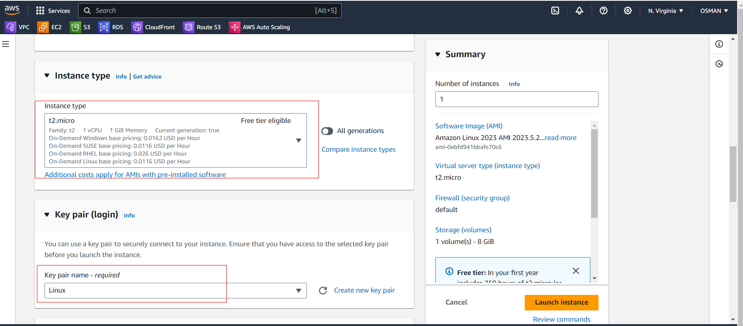

* Select your VPC.
* Select Public Subnet.
* Auto-assign public IP --- enable
* Select security Groups.

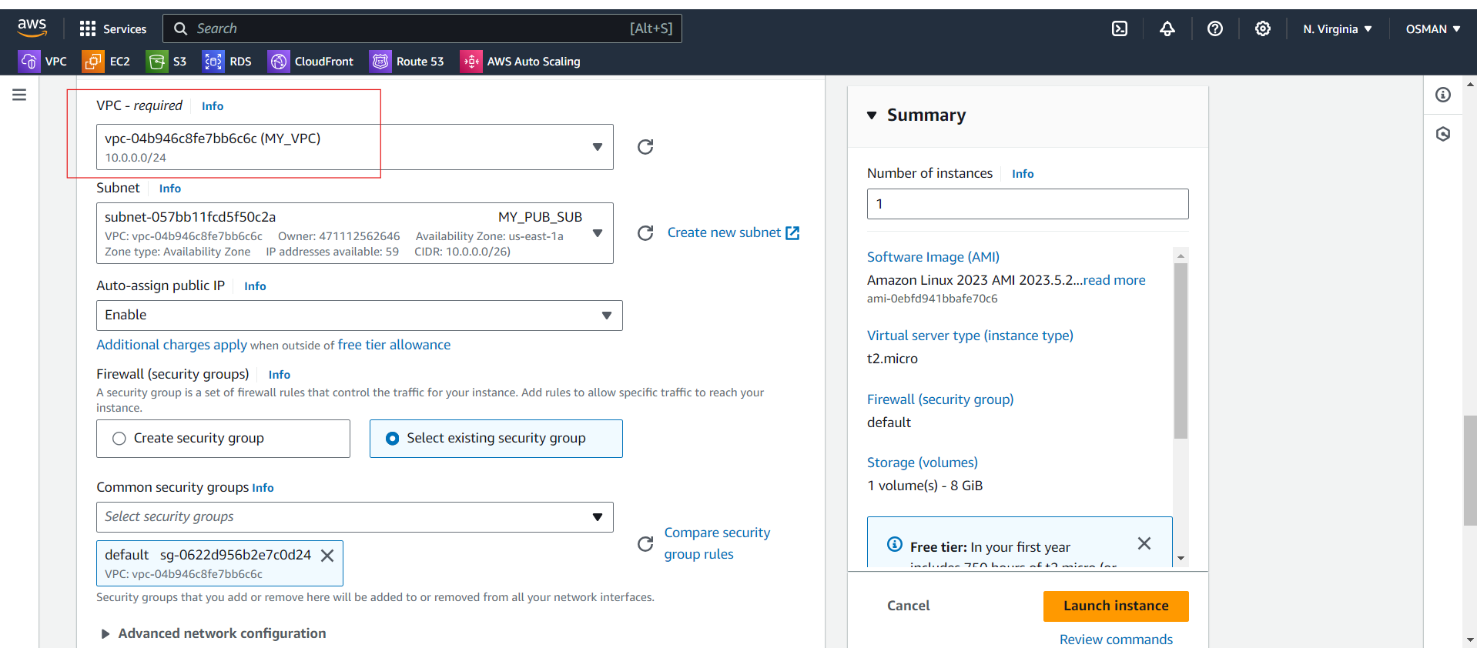

* Next click on Launch instance.

Again you have to launch PVT_SUB_EC2

Here only change

* EC2 instance name--- PVT_SUB_EC2
* Select PVT Subnet.
* Auto-assign public IP --- Disable
* Remainng do as it’s PUB_EC2 configurations.

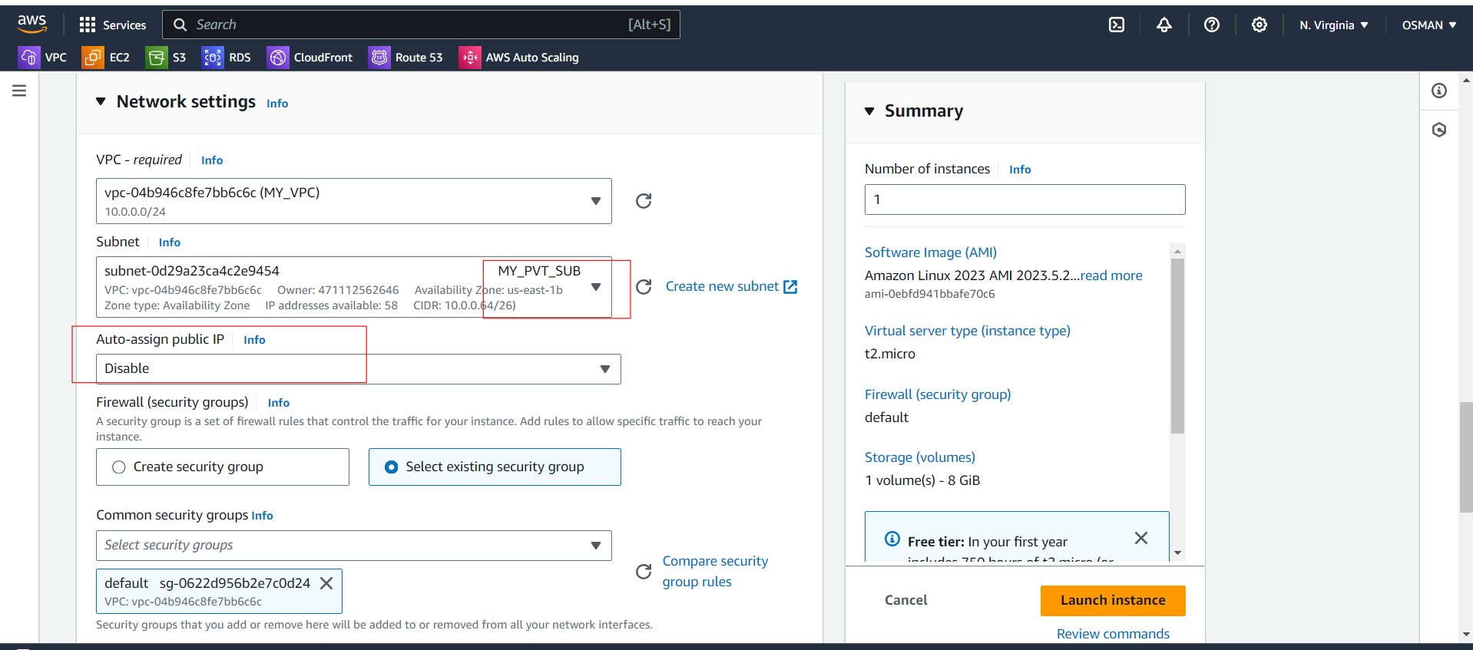

* Click on launch instance.

Here two instances are created.

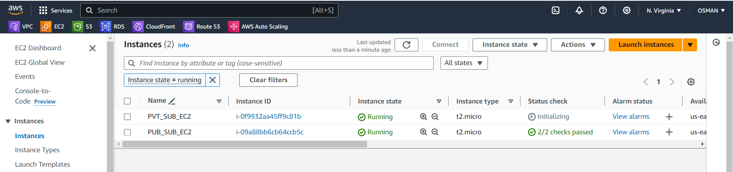

Task is Done.

###############################################

7) Deploy Apache server on both the ec2 instances with sample index.html file.

* Now we have to Deploy Apache server on both the ec2 instances with sample index.html file.
* To do that first connect PUB_EC2 server.
* Here I am installing the httpd ----< CMD – yum –y install httpd

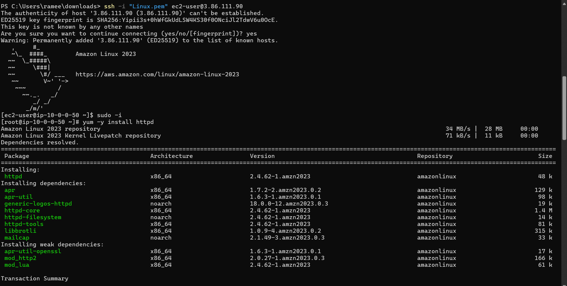

* CMD—systemctl start httpd ------ here I am start the httpd service.
* CMD—systemctl status httpd ------ here I am check the httpd service status.
* CMD --- cd /var/www/html --- these is the default deployment location of the httpd.
* CMD --- cat > index.html ---- < with cat command I am created file and also added content.

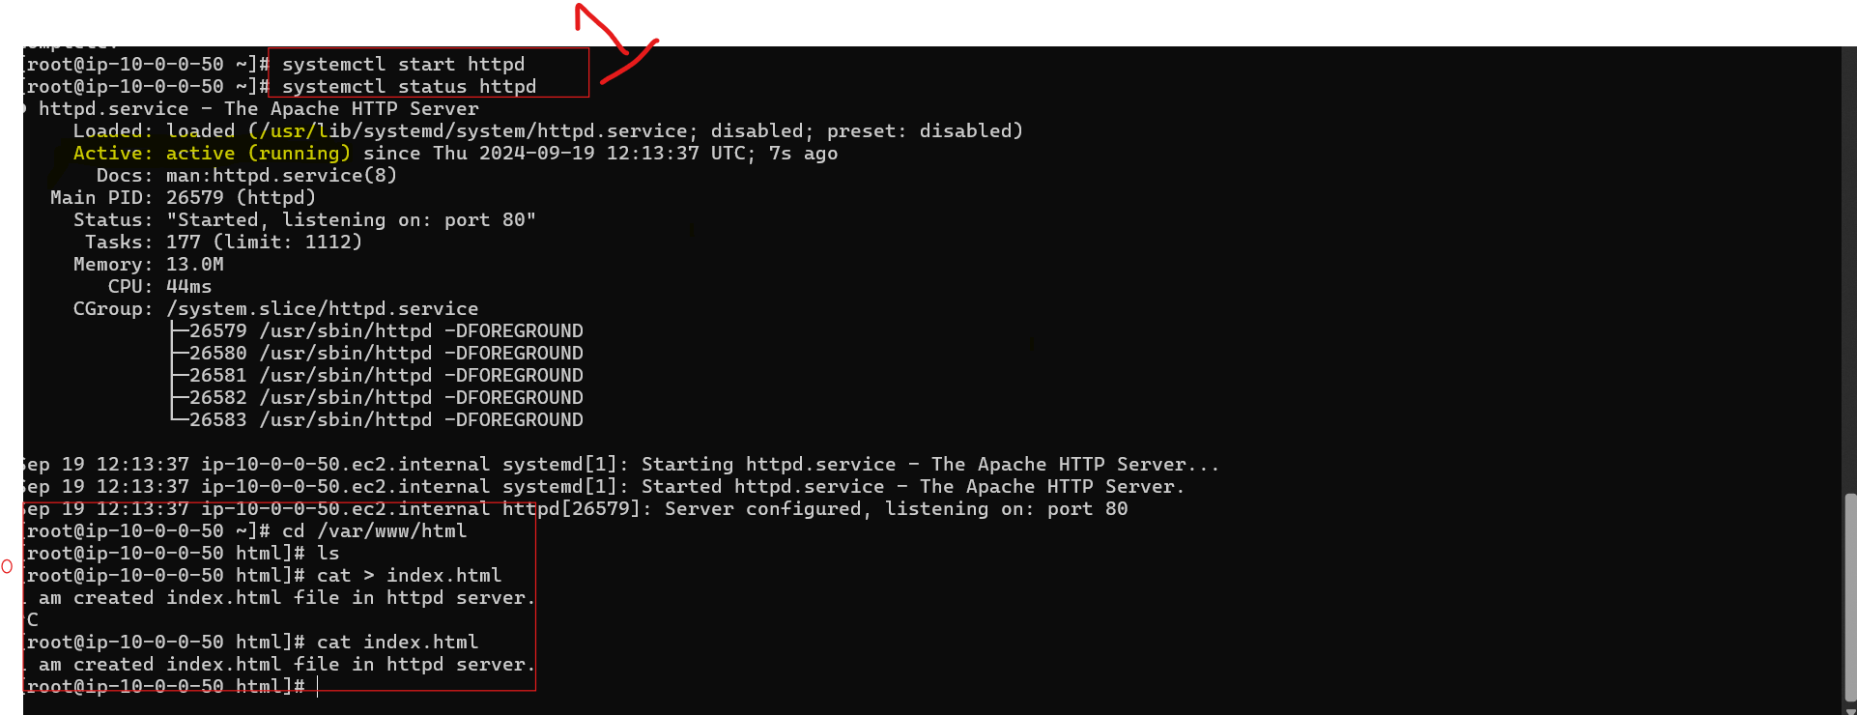

* Now you can browse IP address with PORT number ---- 3.86.111.90:80
* Now you will able to see the index.html content.

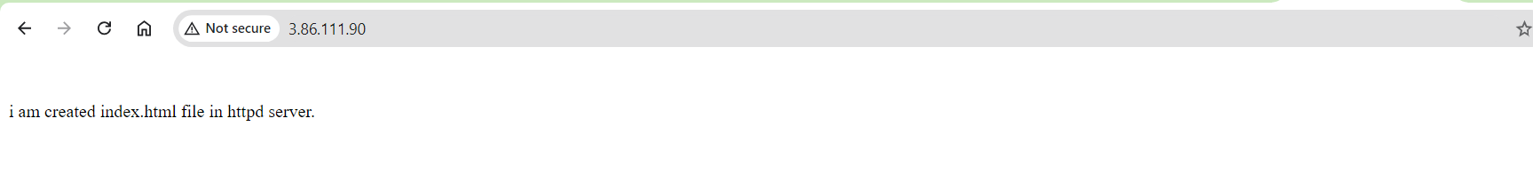

* Now we have to connect PVT_SUB_EC2 .
* We do not connect directly PVT_SUB_EC2.
* To do that we are using jump server--- it’s means we have to connect through public server.
* Local to ec2-instance transfor the pemfile.



Now check .pem file is available or not in PUC_EC2

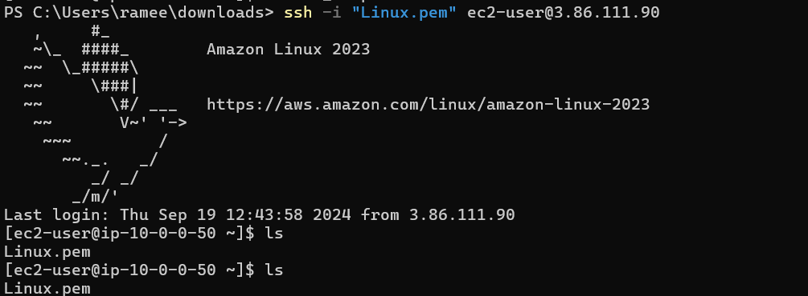

* Now we have to change the permissions of pem file. CMD—chmod 400 <pemfile>
* Try to connect PVT_EC2
* CMD --- ssh -i <pemfile> ec2-user@<PVT_ec2_ipaddress>

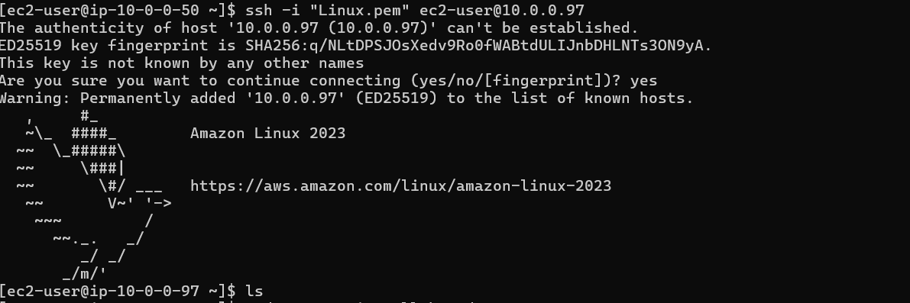

Now we are in PVT_EC2 instance.

CMD--- sudo yum -y install httpd – install httpd server

Here start httpd server and check status

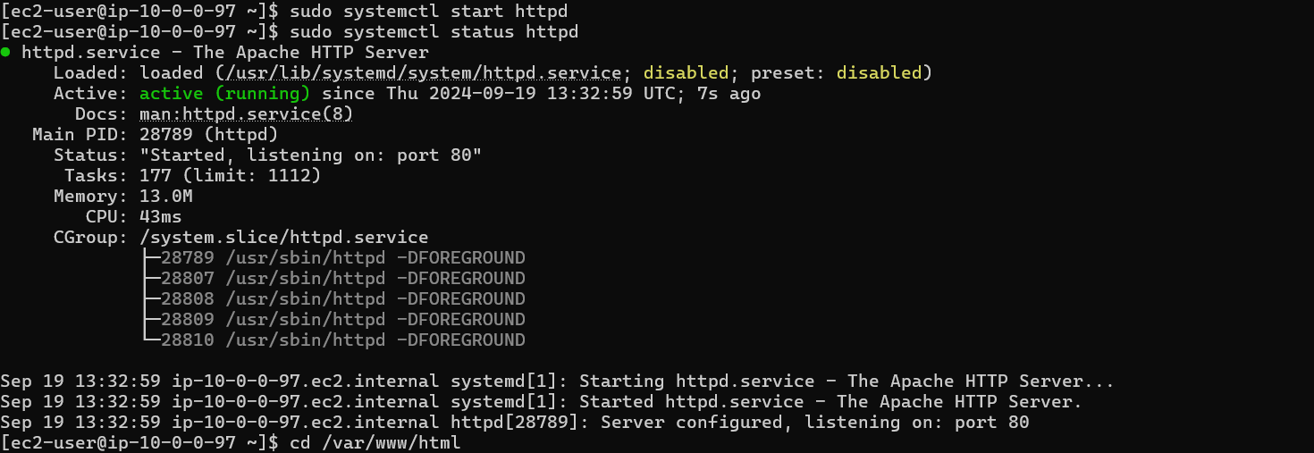

Got to location and create file and see the file.

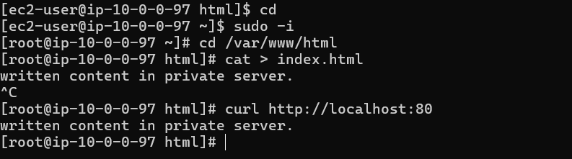

8) Create one application load balancer and attach the load balancer to both the ec2 instances.

* To create application before we have to create Target Groups.
* Click on Target Groups and create target groups.

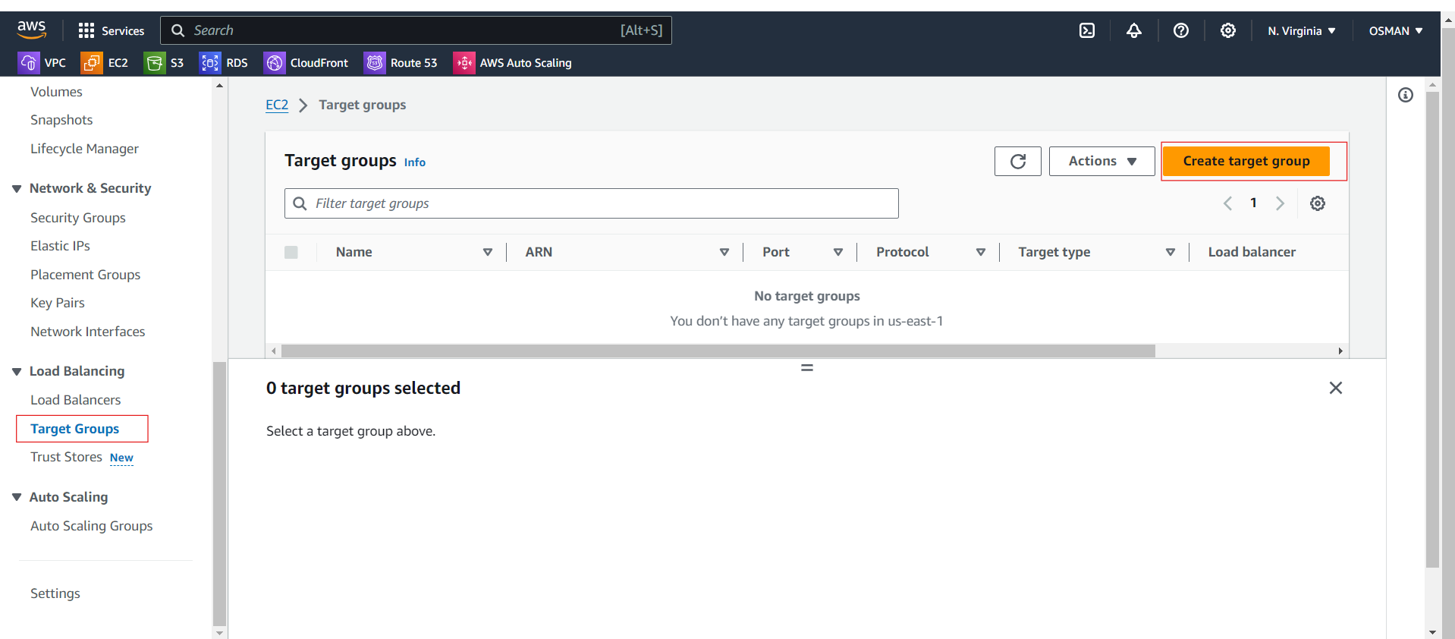

You will see the below interface and select the instances.

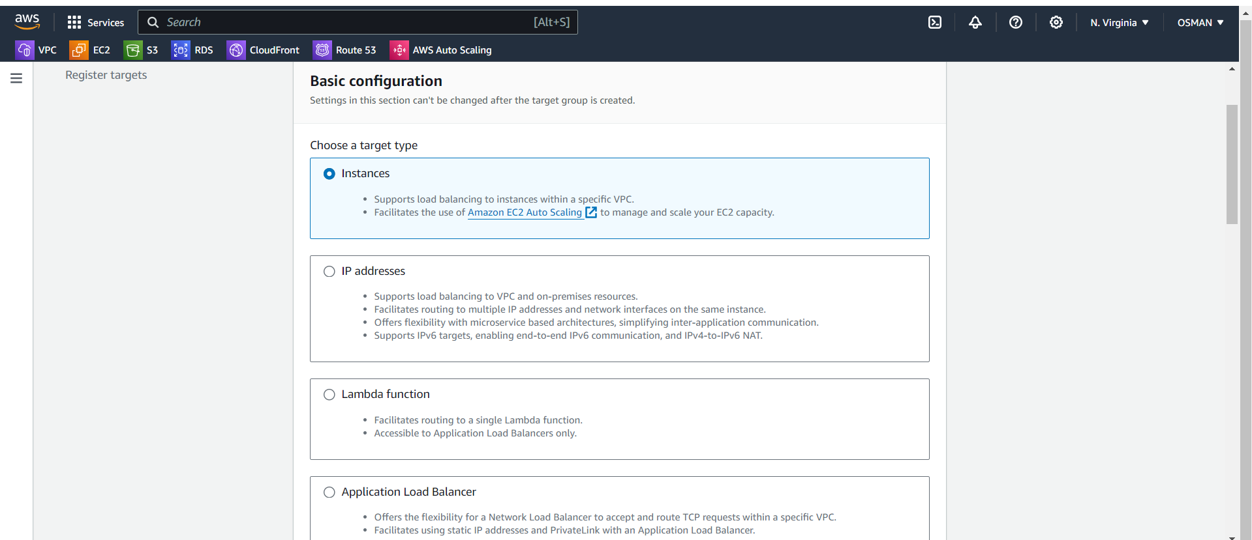

Give Target Name and select where instances is there.

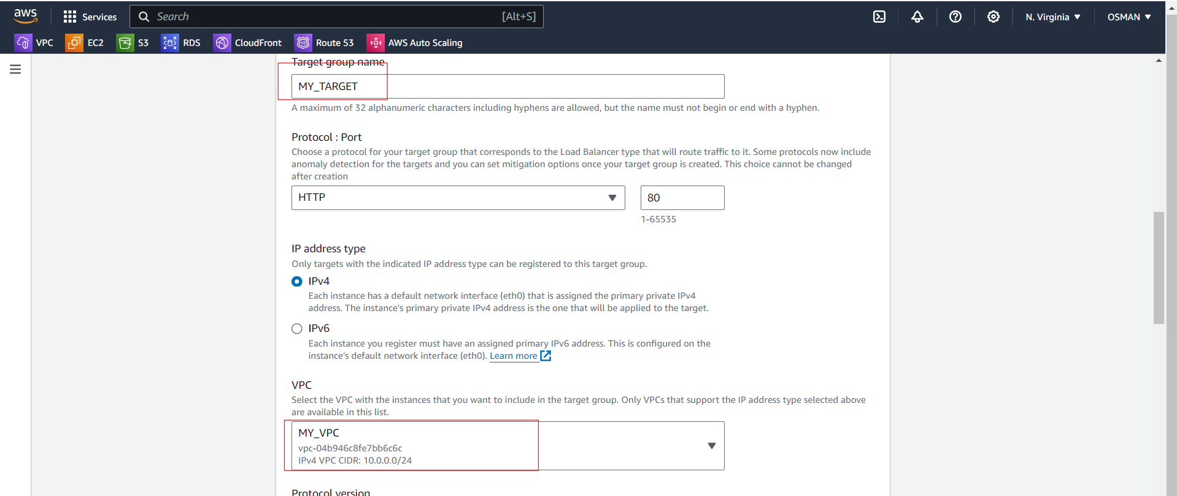

I am given path is index.html

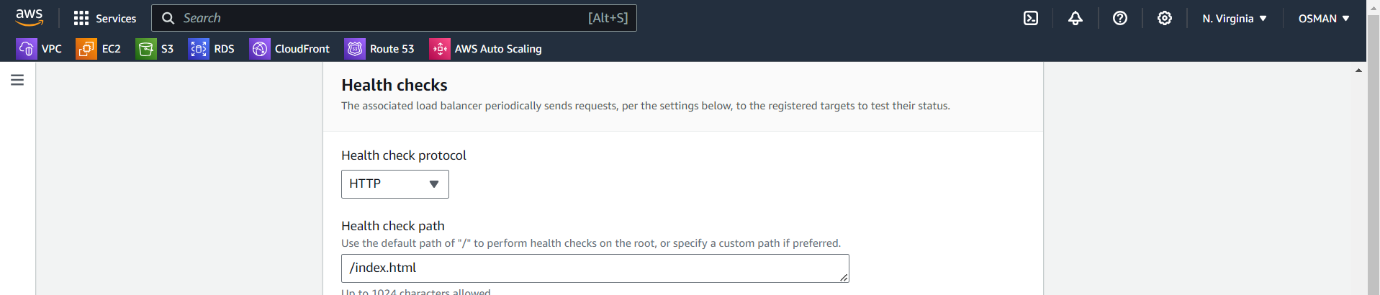

Leave it as it’s and click on next.

Here select the two instances checkbox’s and click on include as pending below.

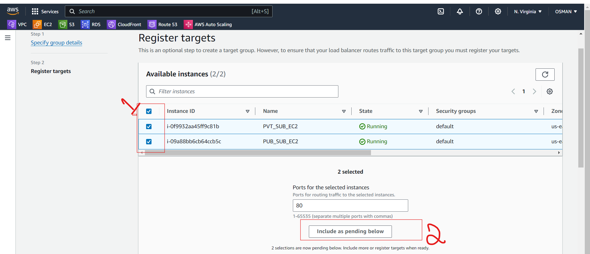

Just click on create target group.

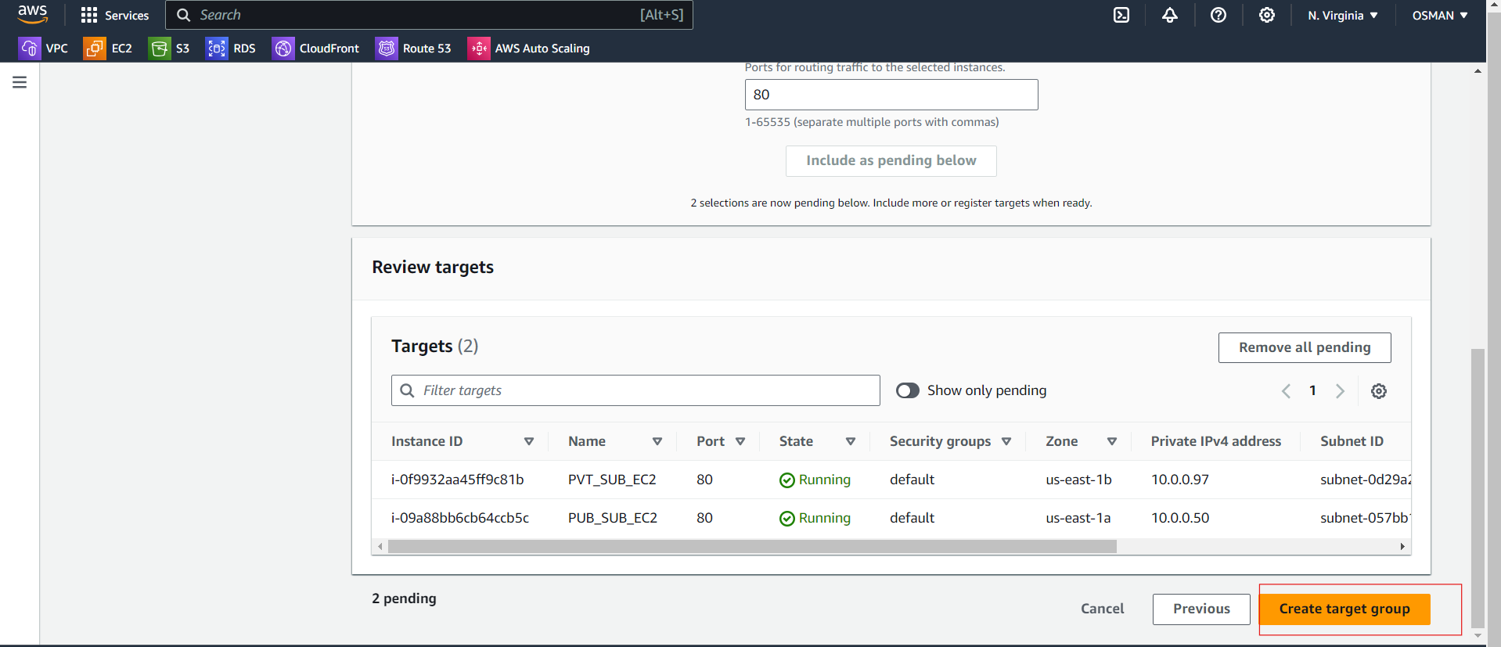

Next click on the Load balancers and create load balancer.

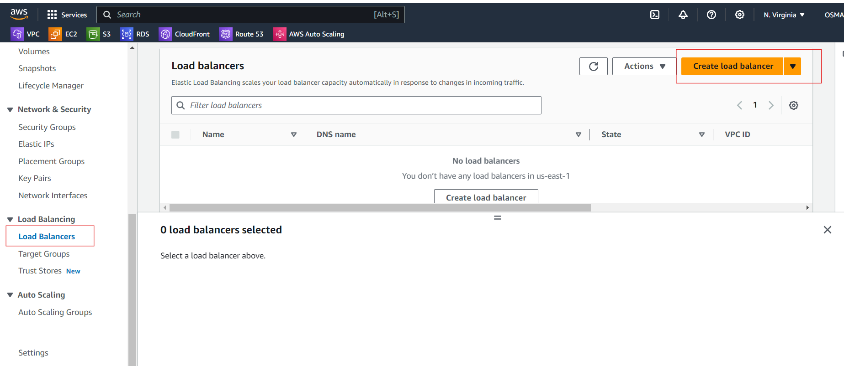

Here you need to select the Application Load balancer.

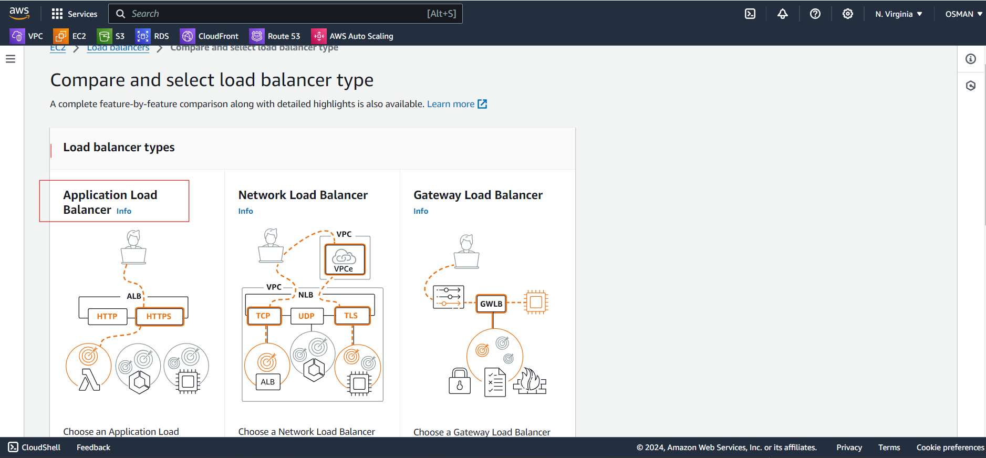

Give load balancer Name and scheme is –internet facing.

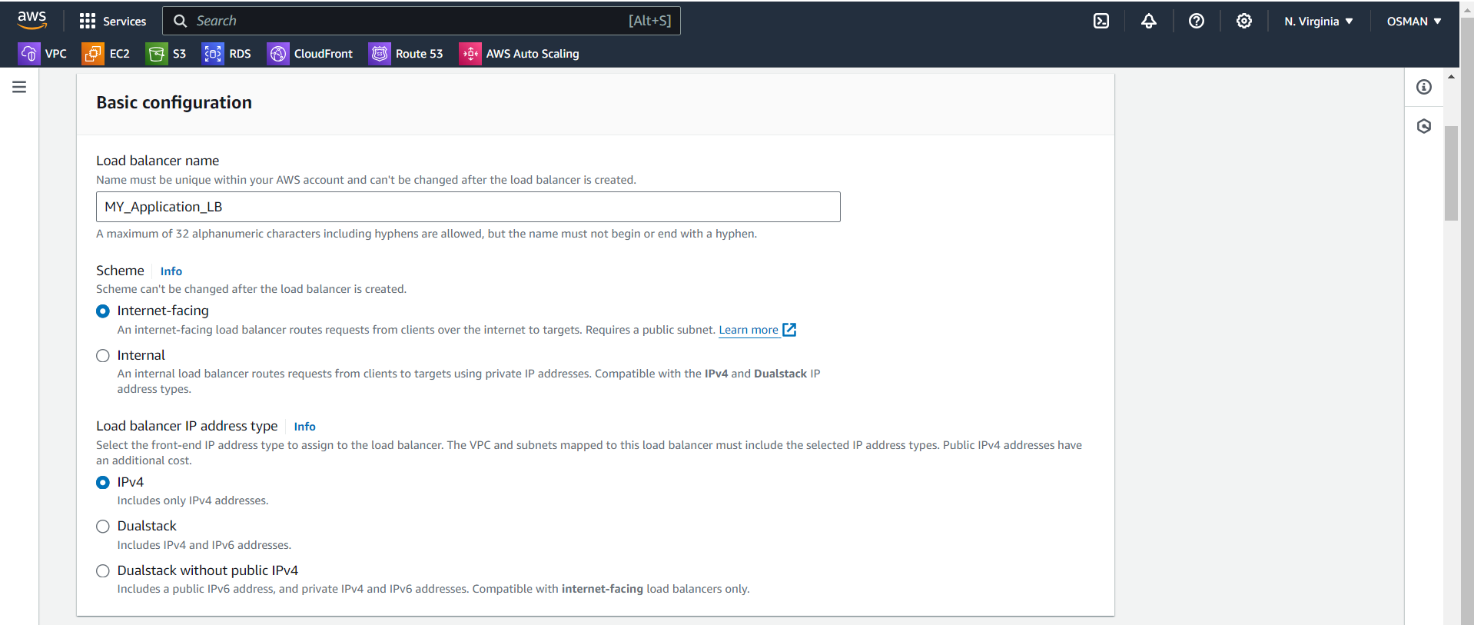

Here select your VPC AND Select Availability Zones.

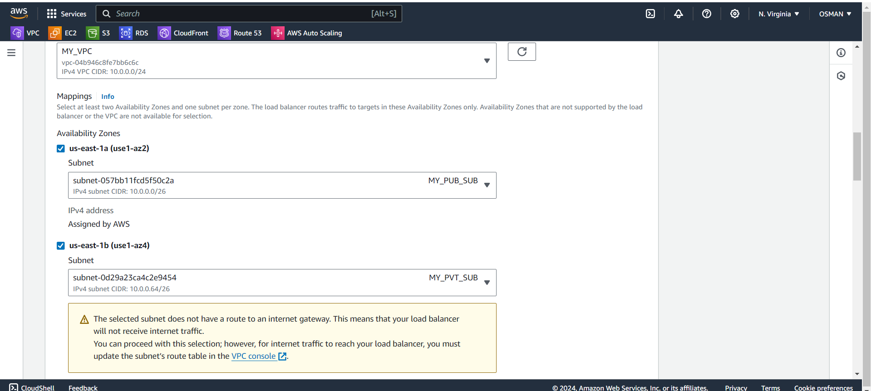

Select security group and target group.

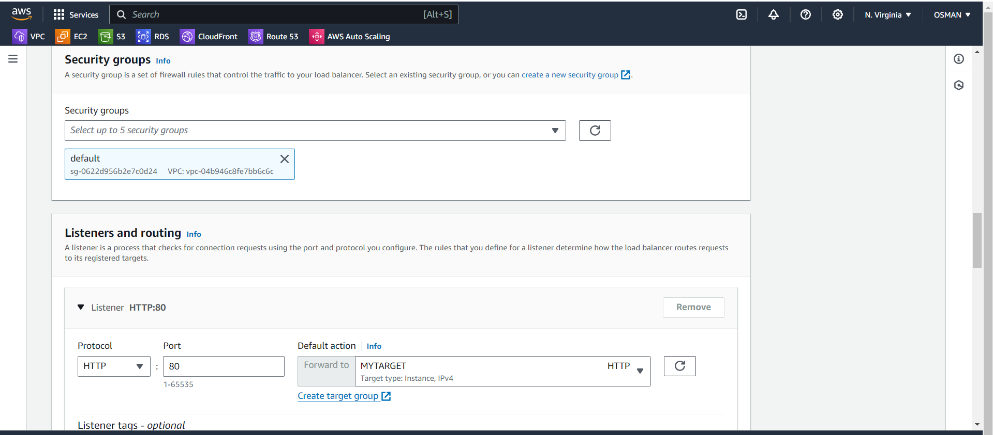

* click on load balancer.
* You can wait still load balancer status is active.

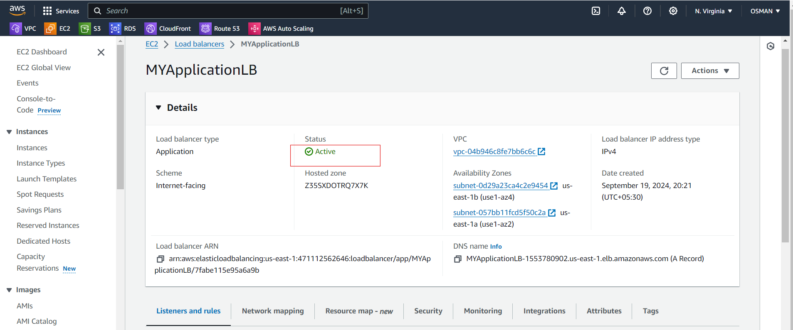

Then copy the DNS name and paste in browser.

You see the PUB_SUB_EC2 server index.html content.

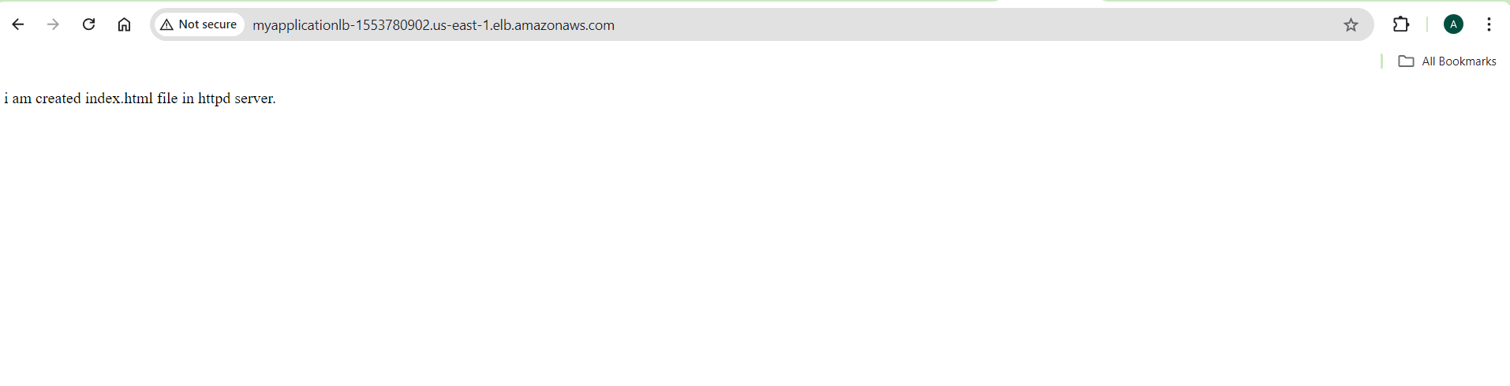

Refresh the Page you will see PVT_SUB_EC2 server index.html content.

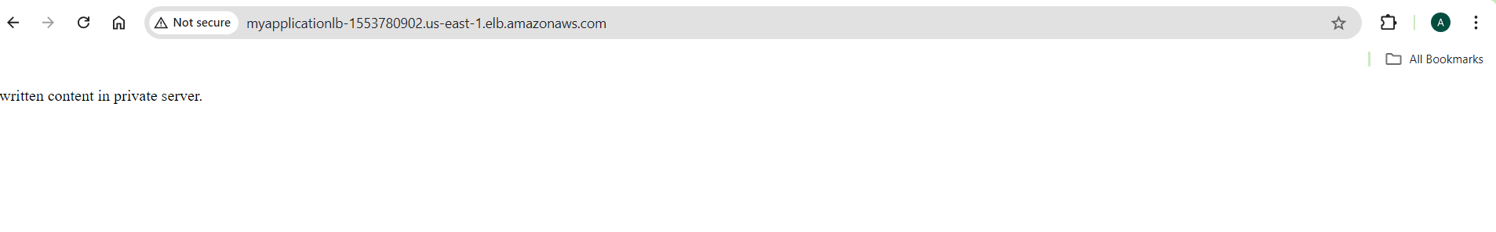

The TASK is DONE#############################

9) Store Application load balancer logs to s3.

* go to Loadbalancers and click on check box off the load balancer.
* Click on the Attributes. 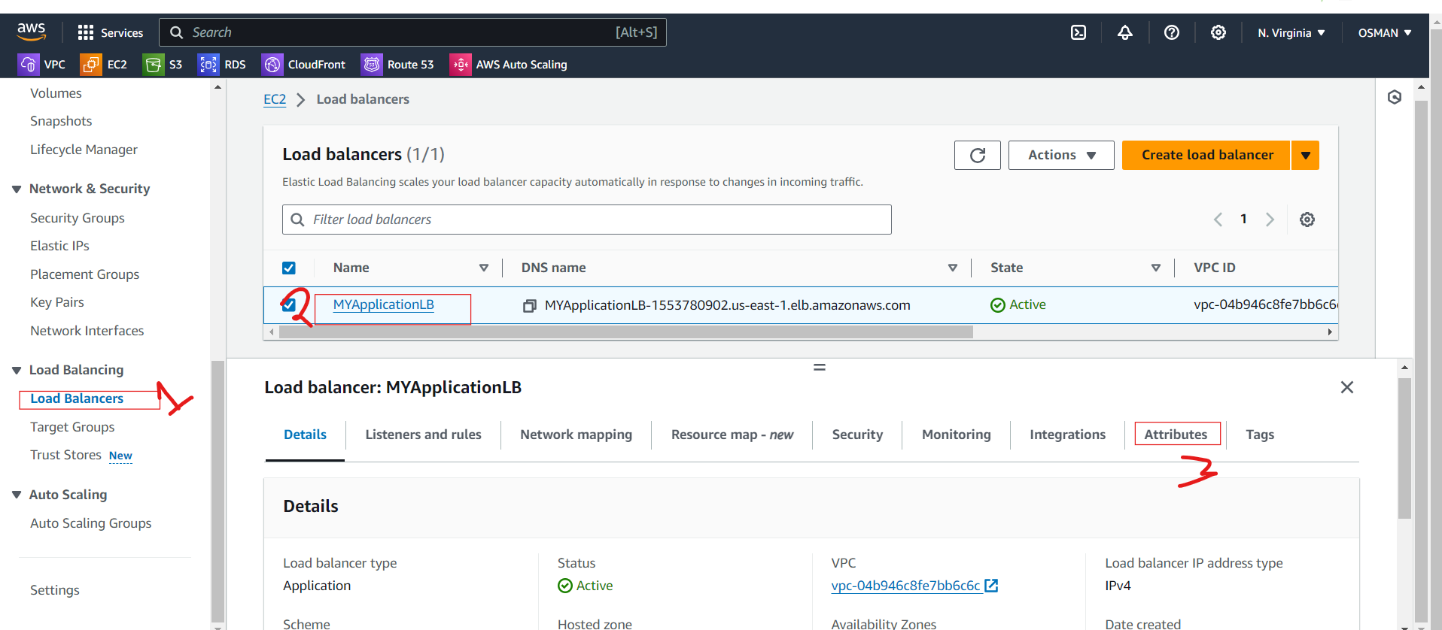

Click on edit Option.

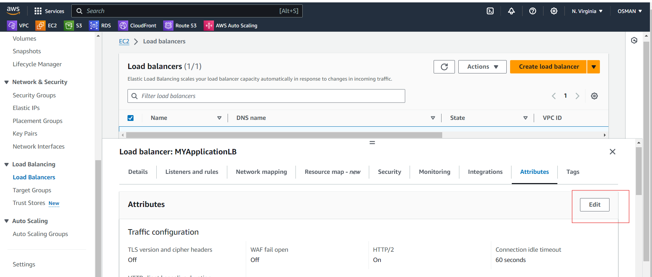

* Go to the Protections in the below enable Access logs.
* If you have already S3 bucket with in the same region select that one.
* Here bucket you have to give the bucket permissions.

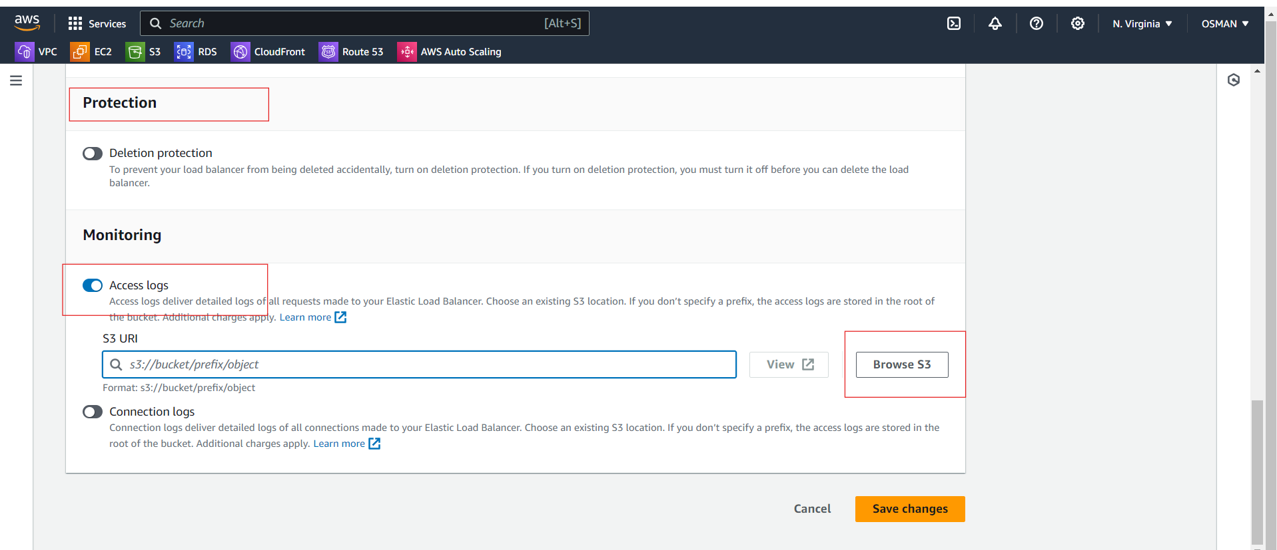

Now I am creating the new bucket with permissions.

I went to bucket and updated the bucket permissions.

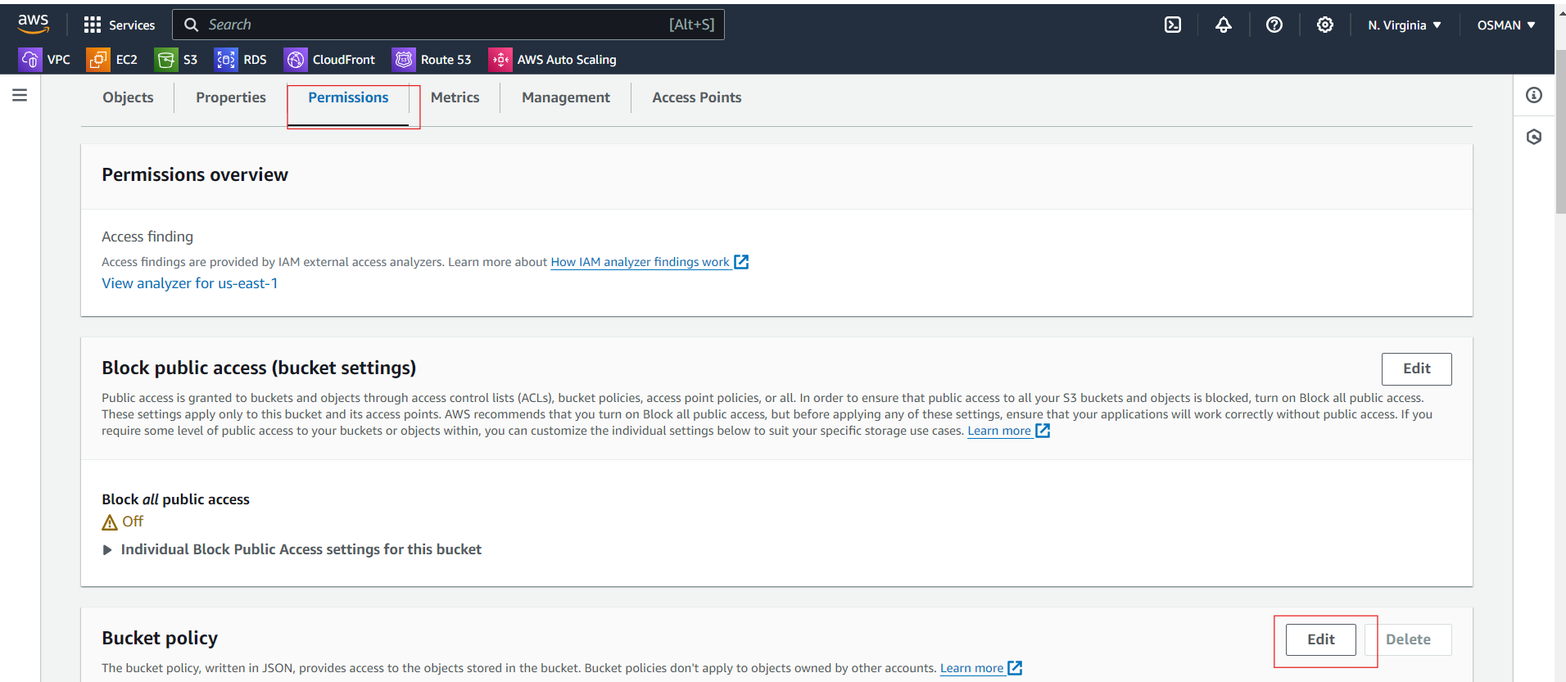

<https://docs.aws.amazon.com/elasticloadbalancing/latest/application/enable-access-logging.html>

Scroll down below you see the --- Regions available before August 2022.

Copy the policy.

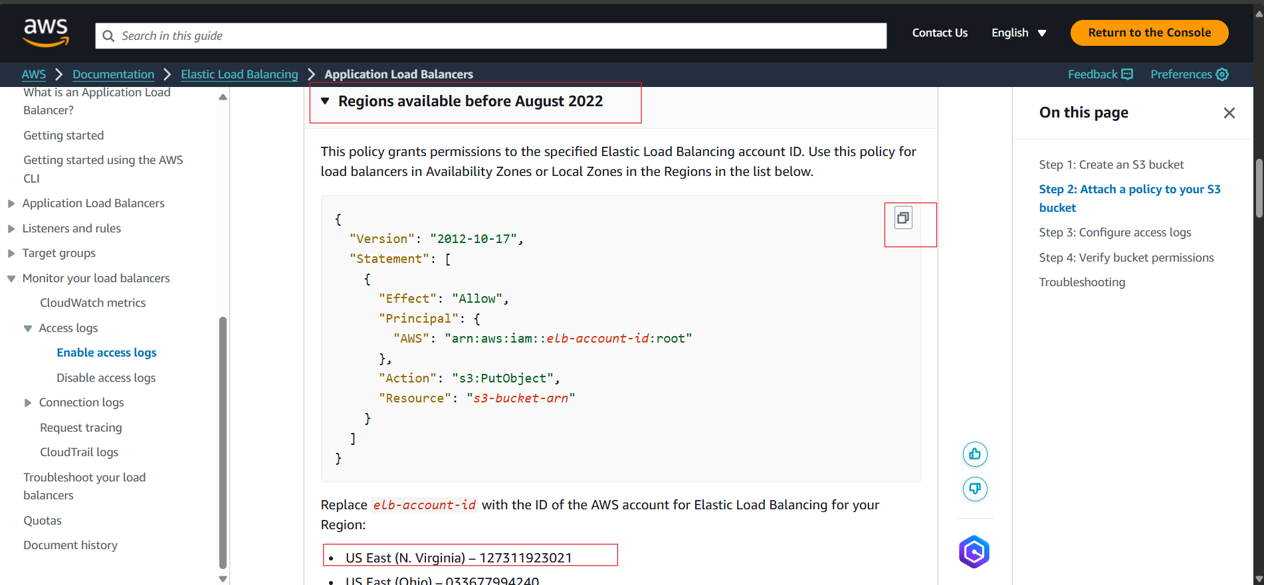

* Go to the Bucket properties and click on edit policy.
* Based on the Region you have to give elb-account id.
* Resource is your bucket name and click on save changes.

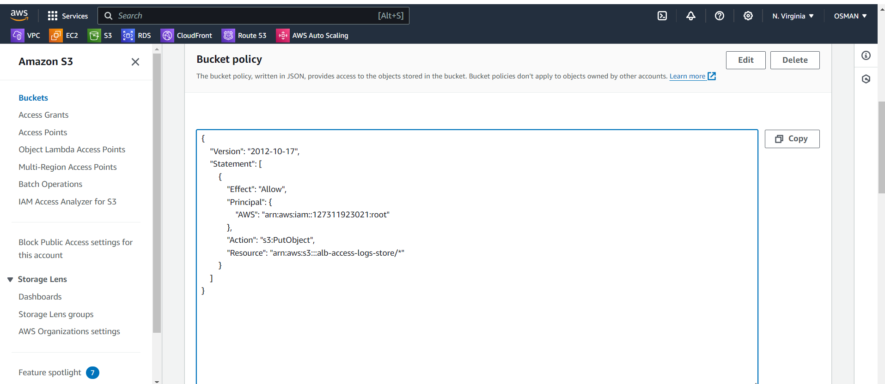

Now come and select the bucket and click on save changes.

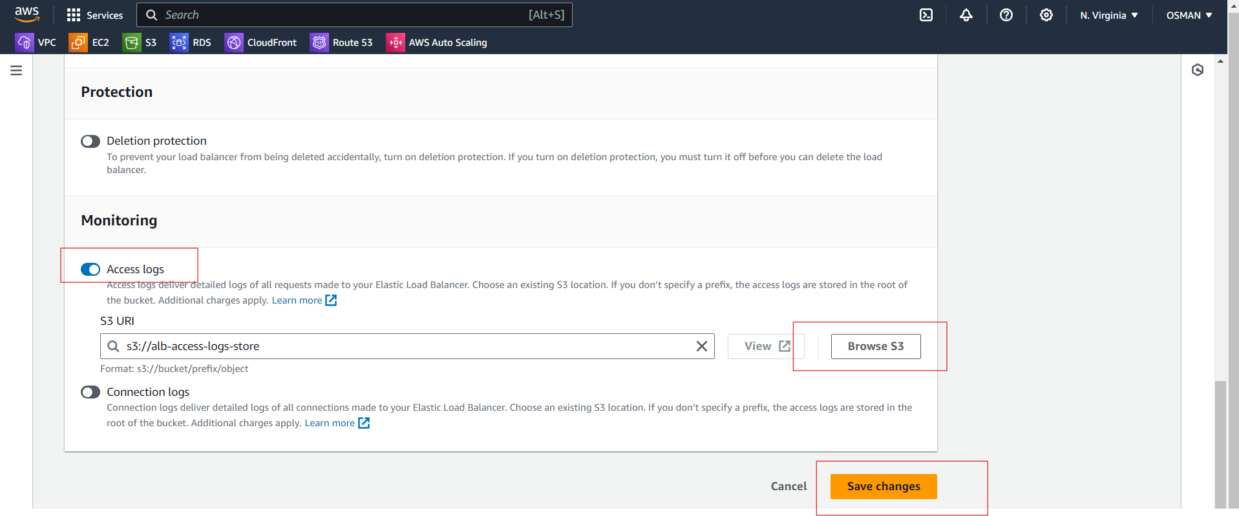

Now go to the s3 bucket and check there your logs file is created or not.

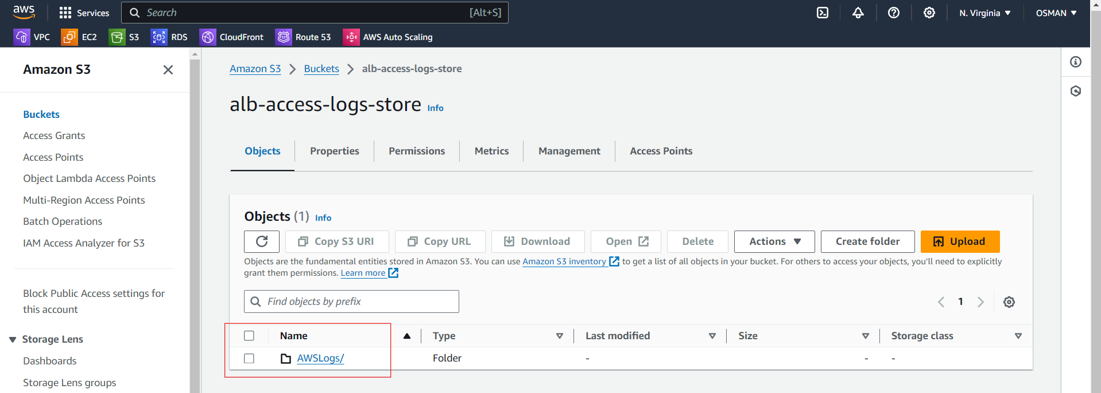

Log file is created.

#############Task is Done ############

10) Store the vpc flow logs to cloudwtach group.

* Go to the VPC and select VPC.
* The below you able to see the flow logs and clock on create flow logs.

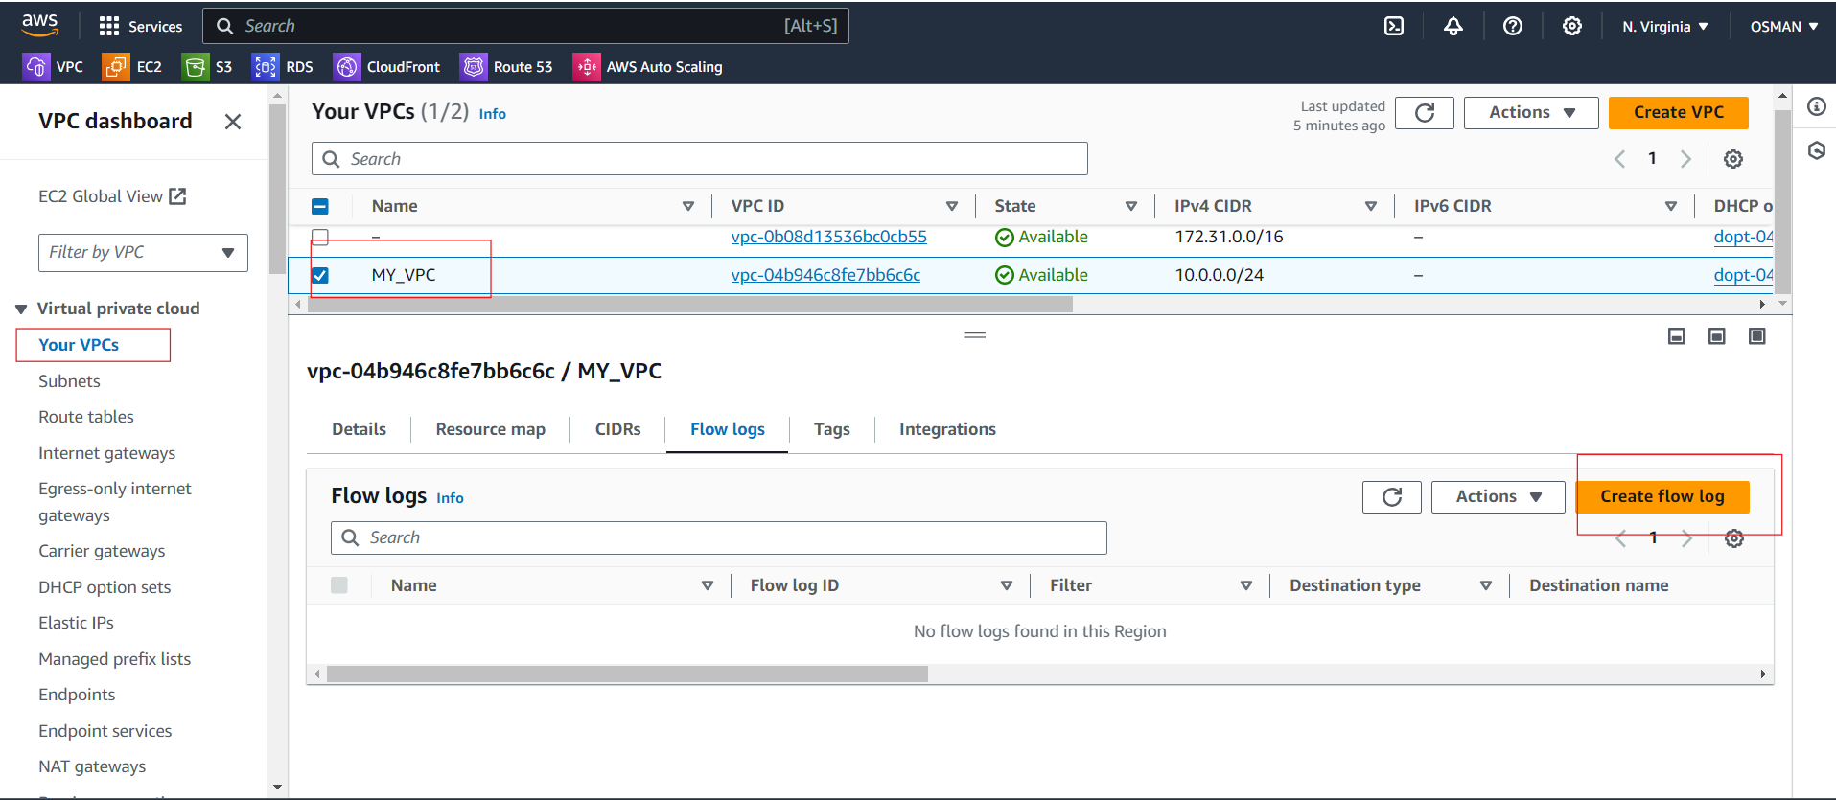

Now go to the google search for policy.

<https://docs.aws.amazon.com/vpc/latest/userguide/flow-logs-iam-role.html>

To create a IAM Role we are generate a new policy. Click on the above link and copy the policy.

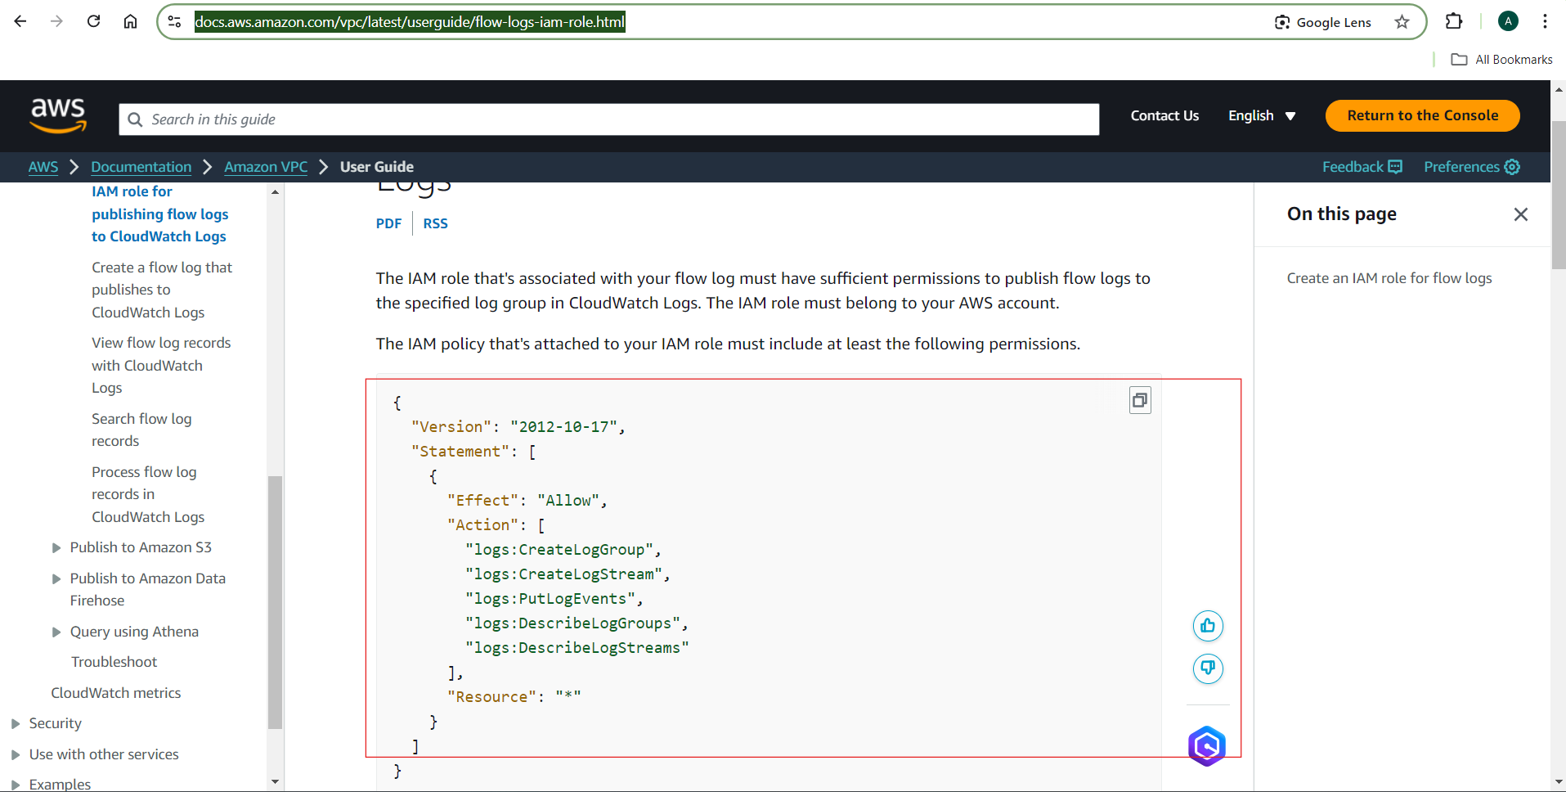

Go IAM and create the policy after that attach the policy for IAM role.

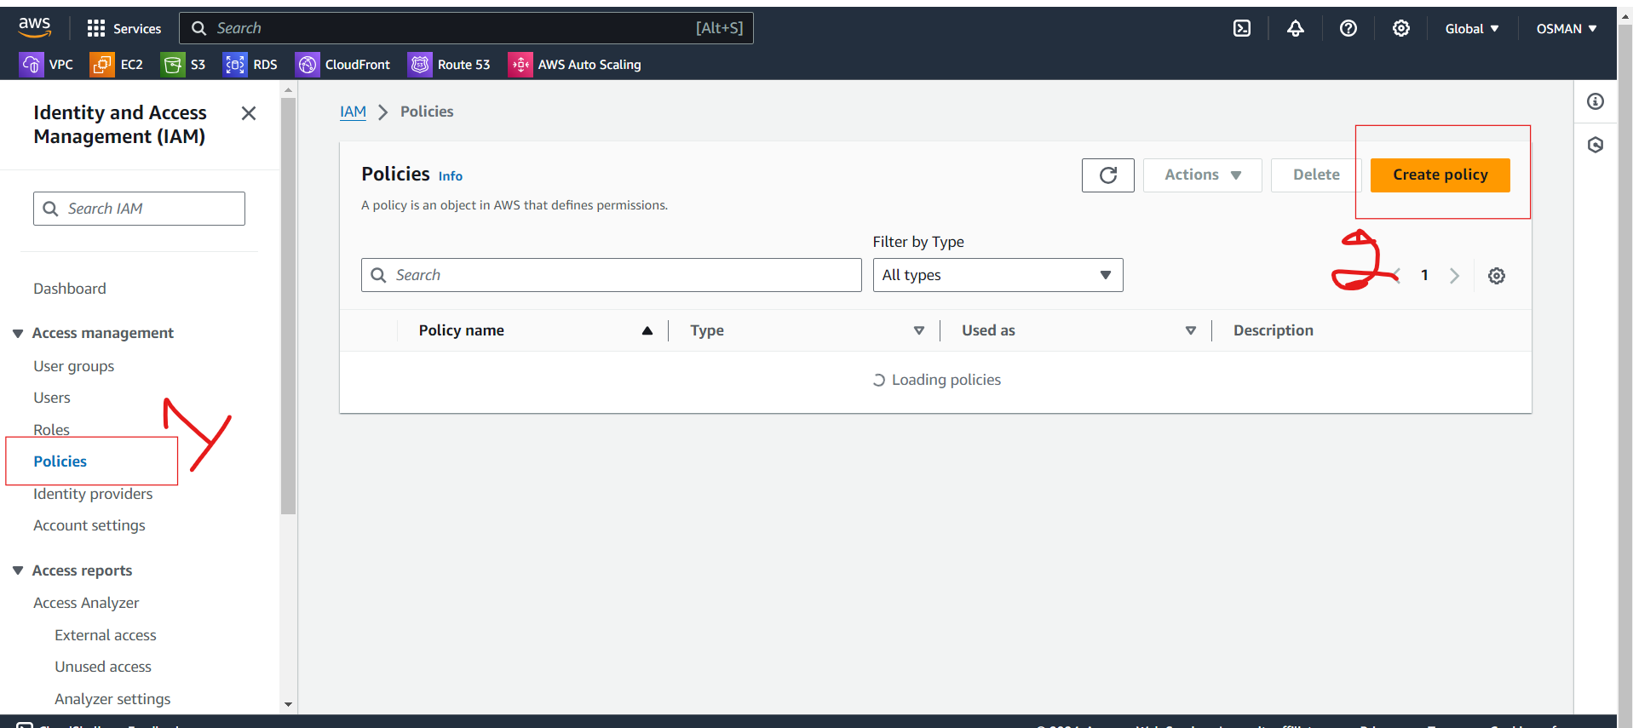

Click on JSON and paste the policy and click on Next.

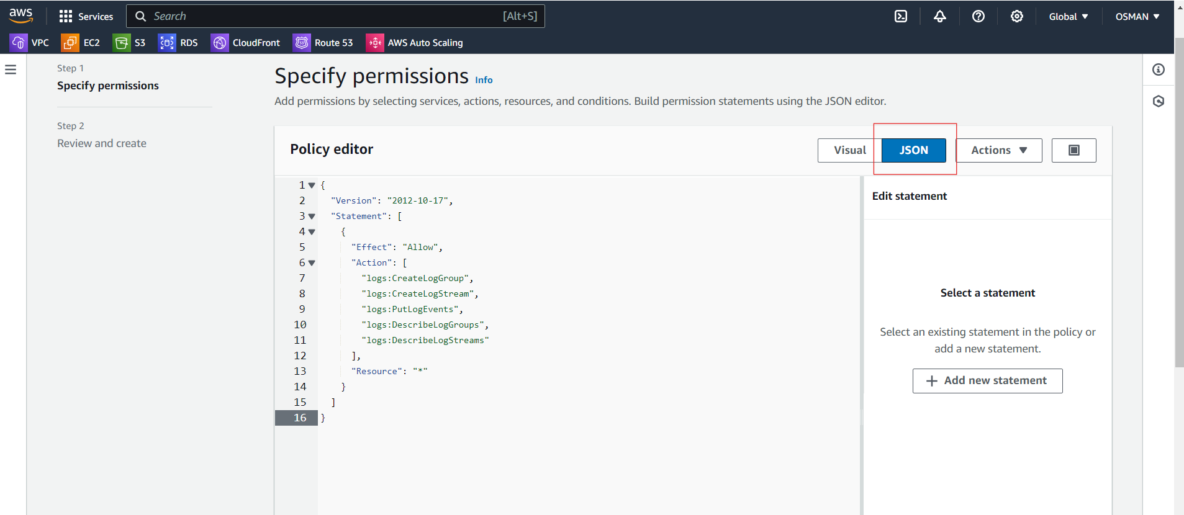

Give policy name and click on create policy.

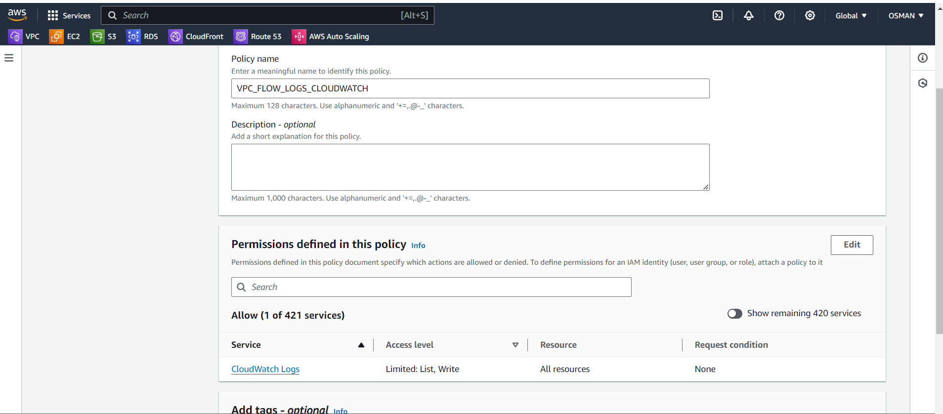

Your policy is created.

Now create Role.

GO to the Roles and create Role. While creating role attach the policy what we created.

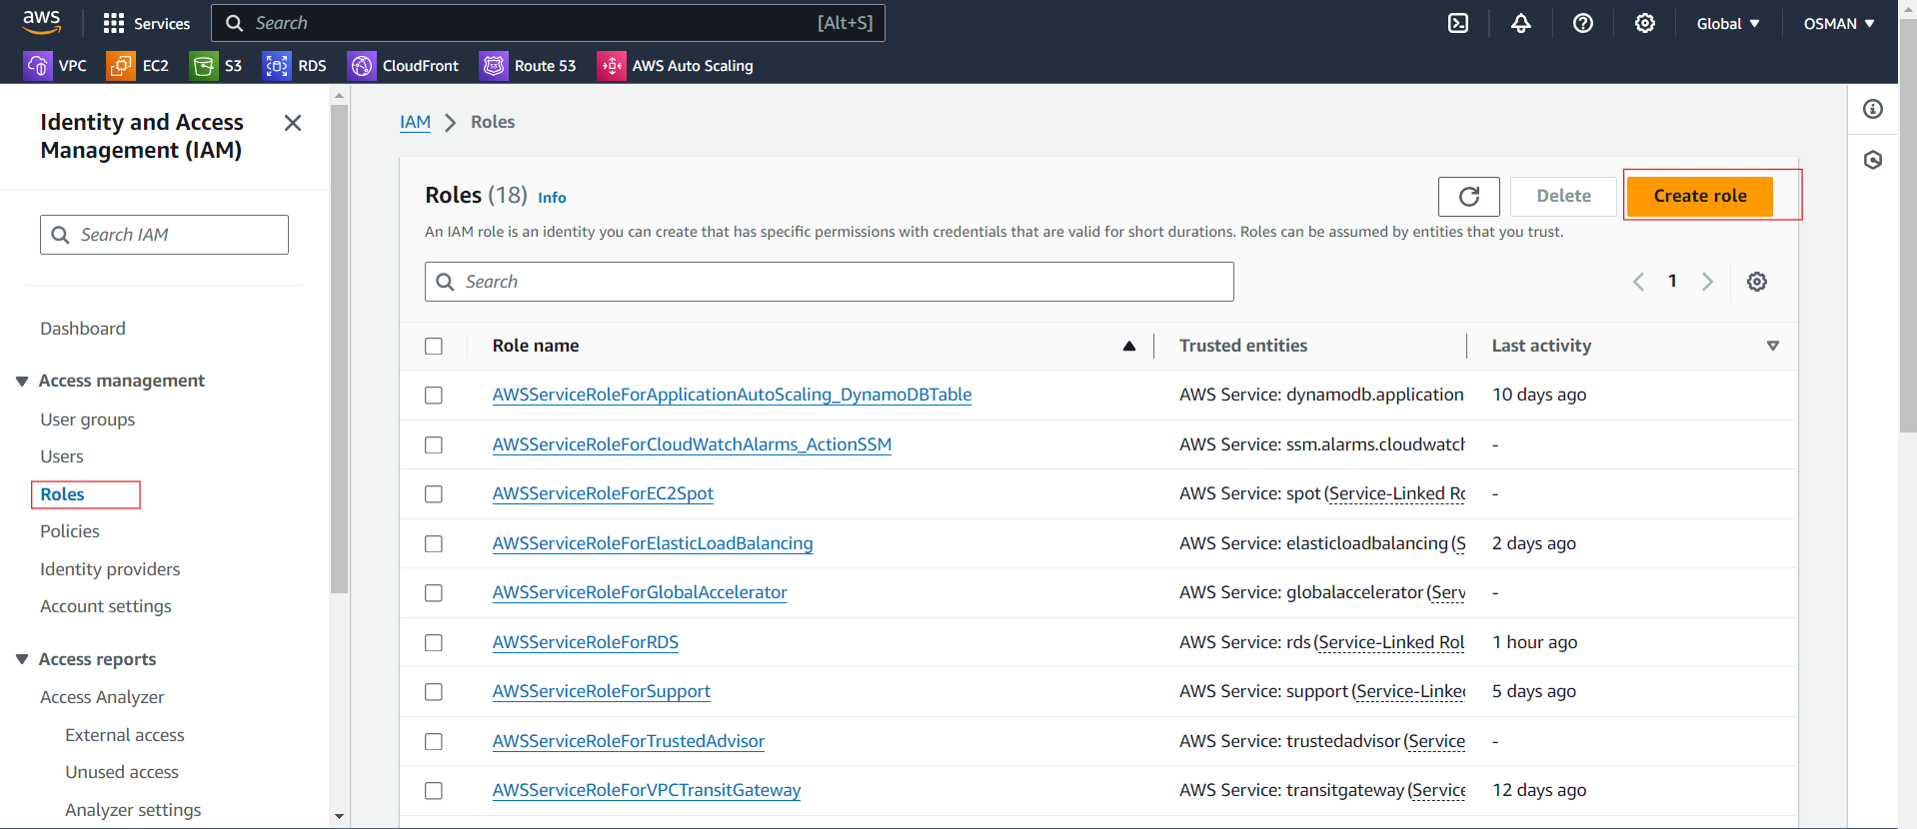

You need to select custom trusted policy and paste these code.

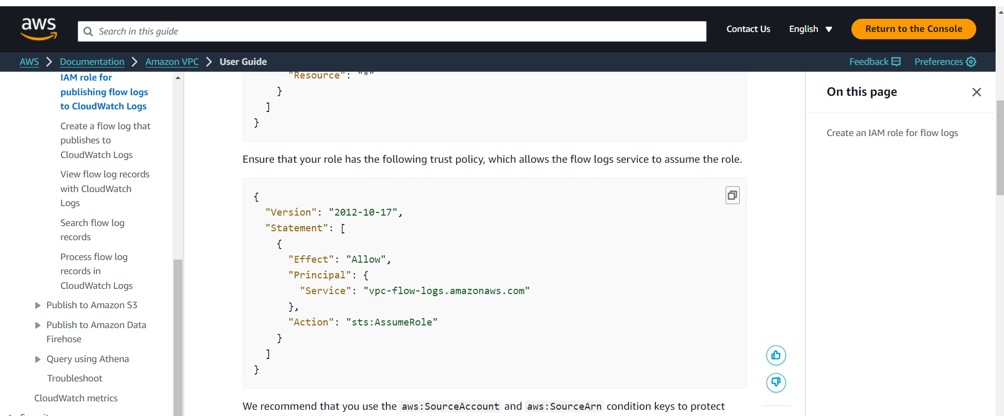

Paste and click on Next.

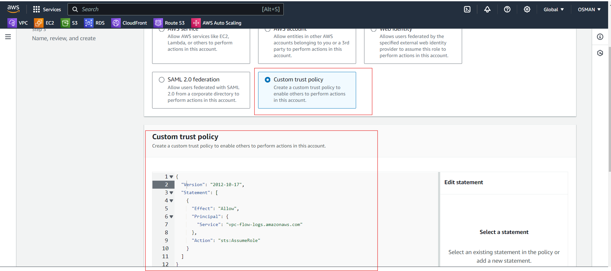

Here select the Policy and click on Next.

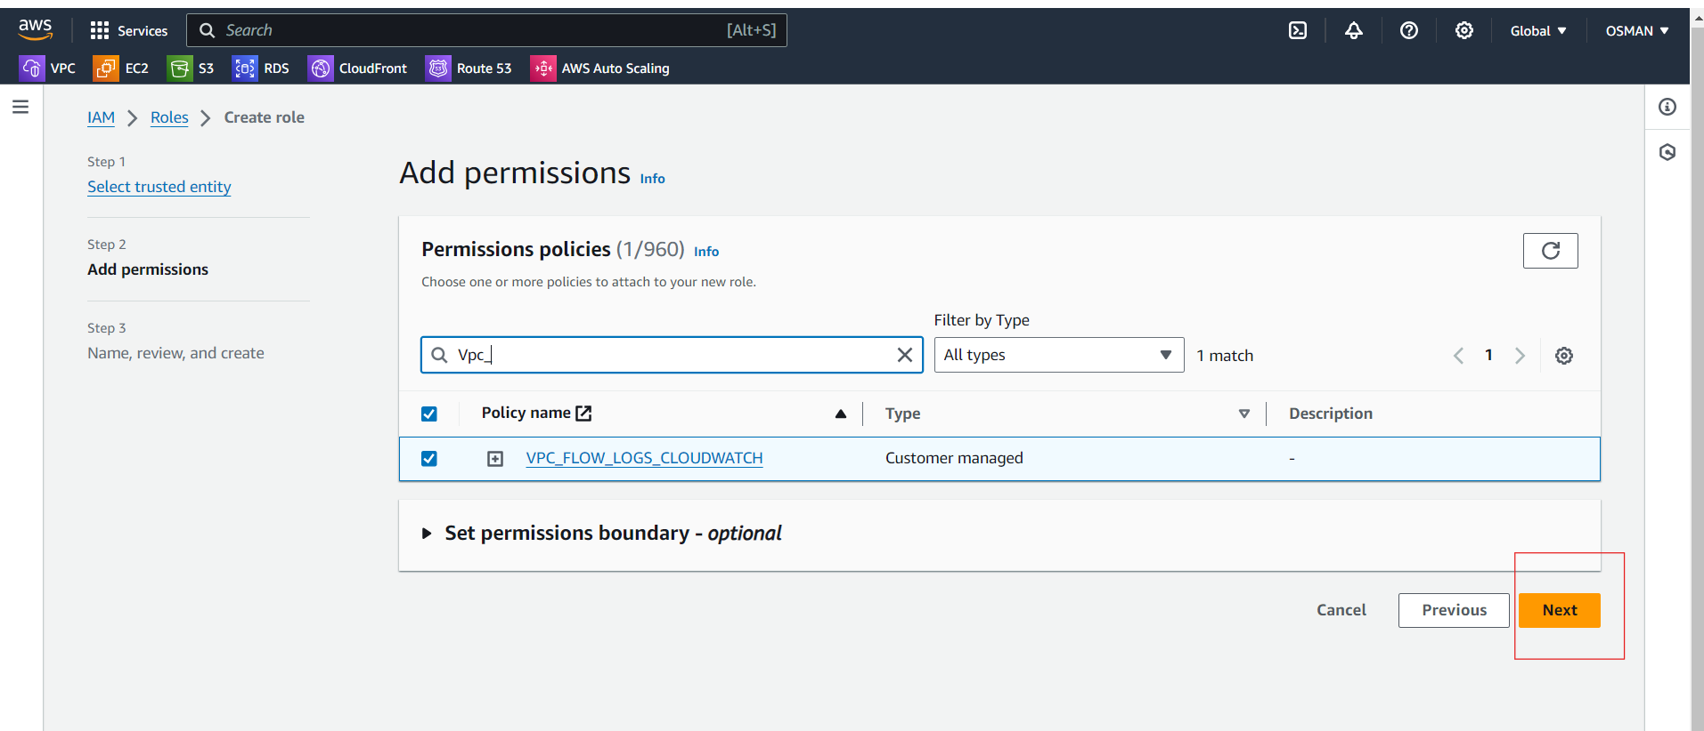

Give role and click on create role.

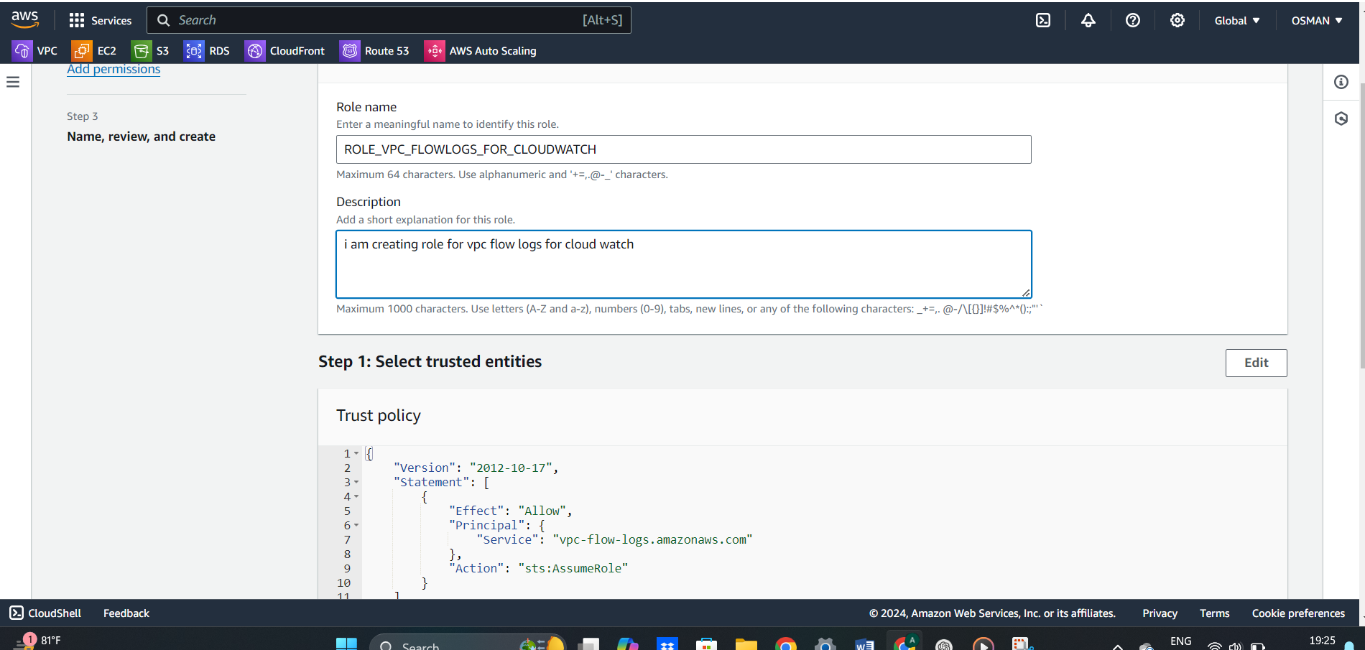

* Now go to the vpc flow logs and click on create.
* Give name --- what you want give me.
* Filter -- give all.
* Maximum aggregation interval --- give 1 min .
* Destination—Send to Cloudwatch Logs.

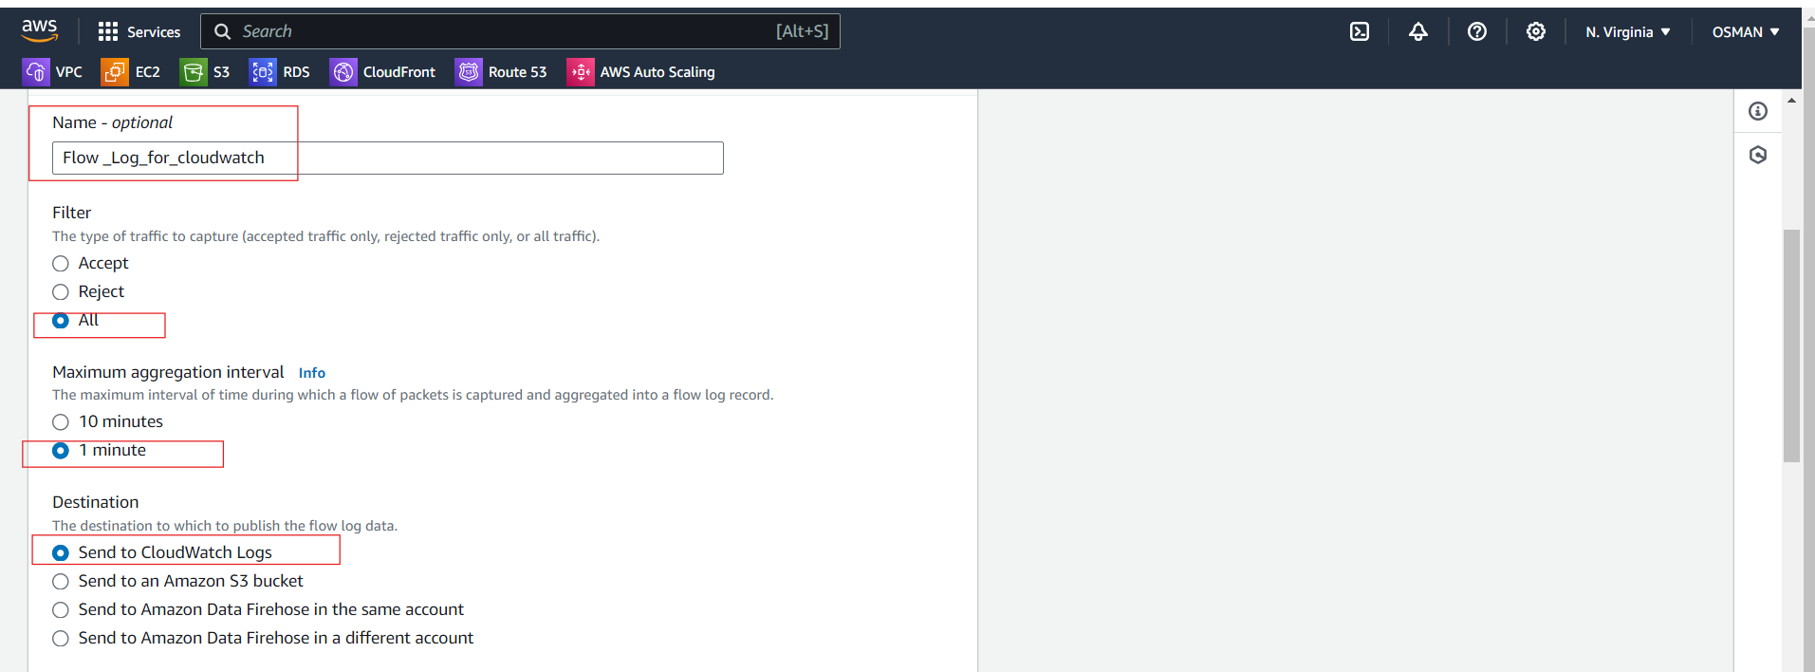

* Now go to the cloud watch and create Log group.
* After that come VPC flowlog and select here the cloudwatch log group.

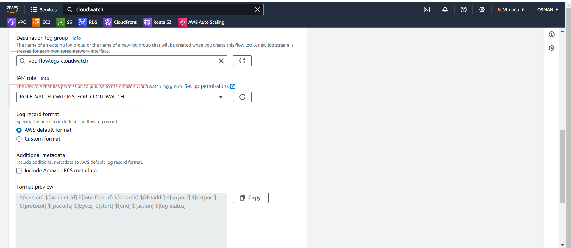

Click on create Vpc flow logs.

Here you can see the flow log.

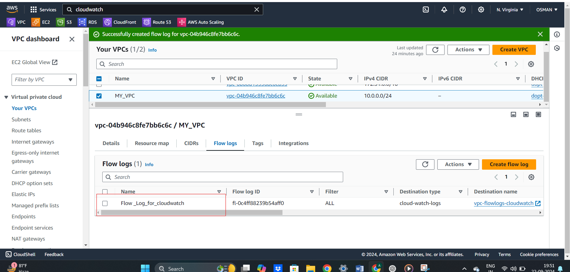

Go to cloudwatch and there you found logs.

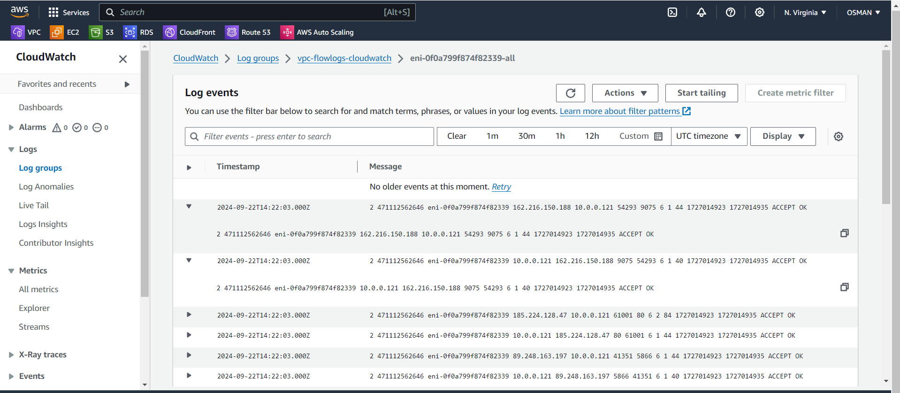

11) Create Monitoring Dashboards to monitor cpu utilization and to monitor apache service.

First create ec2 instance and create monitoring Dashboard.

I have Already Ec2 instance.

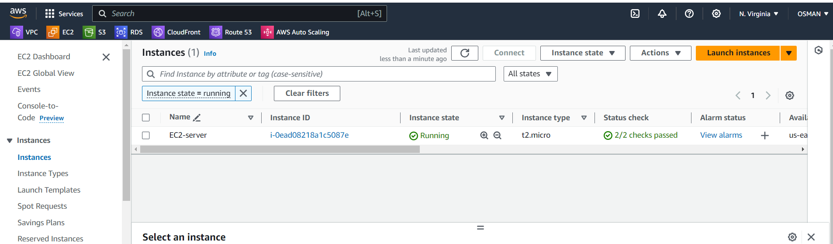

Go to the cloudwatch and create Monitoring Dashboard for ec2.

Click on create Dashboard.

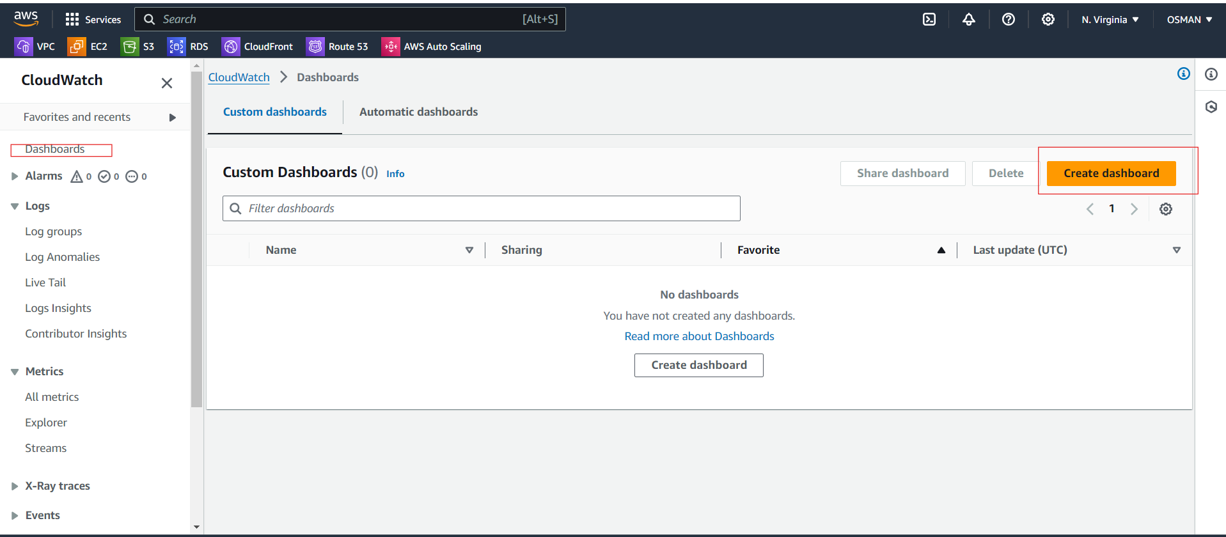

Just give Name for Dashboard and click on create.

Go to the dashboard and click on Add a first widget.

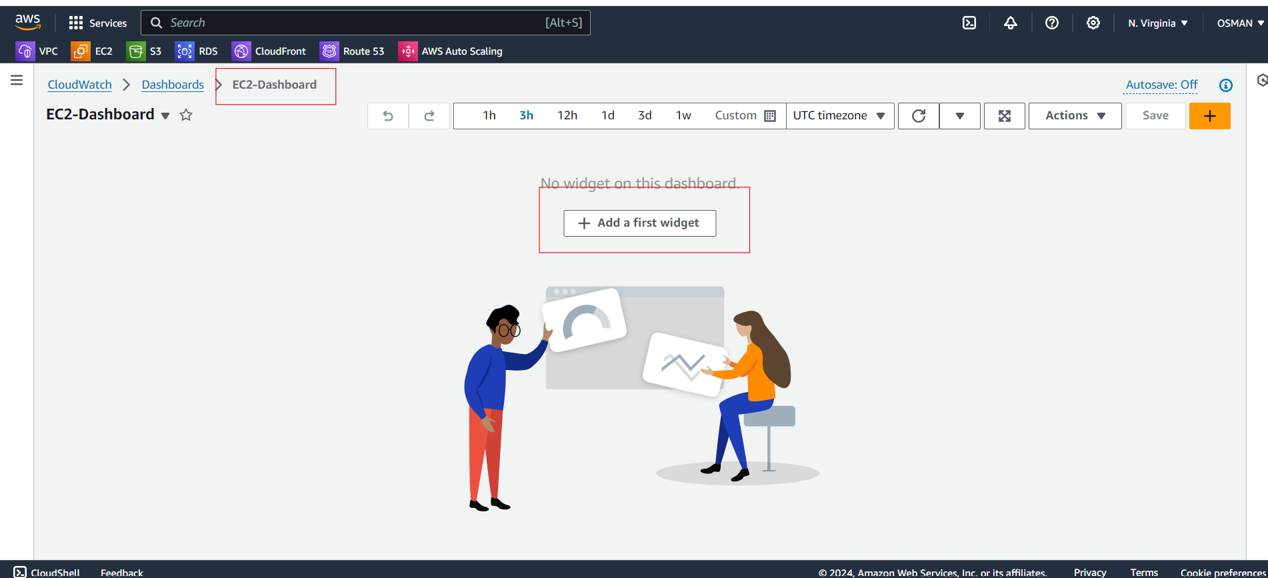

For easy understand I am selecting the number and click on next.

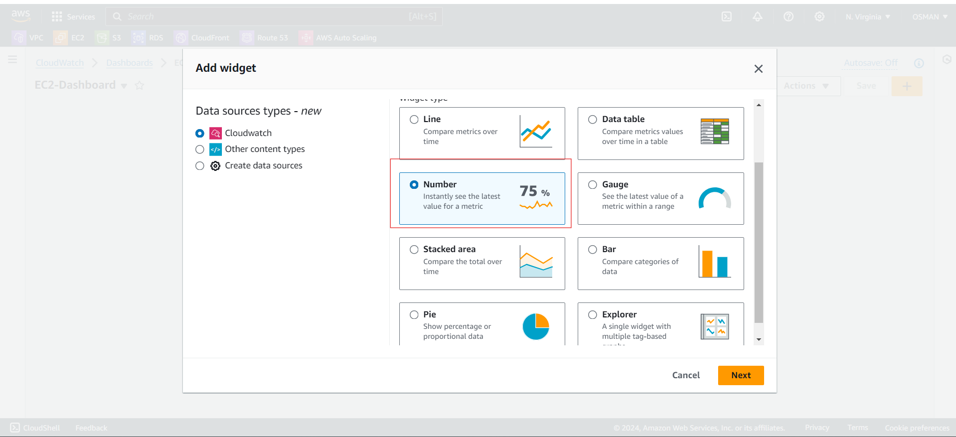

Select Ec2, pre-instances metrics, and give instance id and select Ec2 cpu utilization.

Click on create widget.

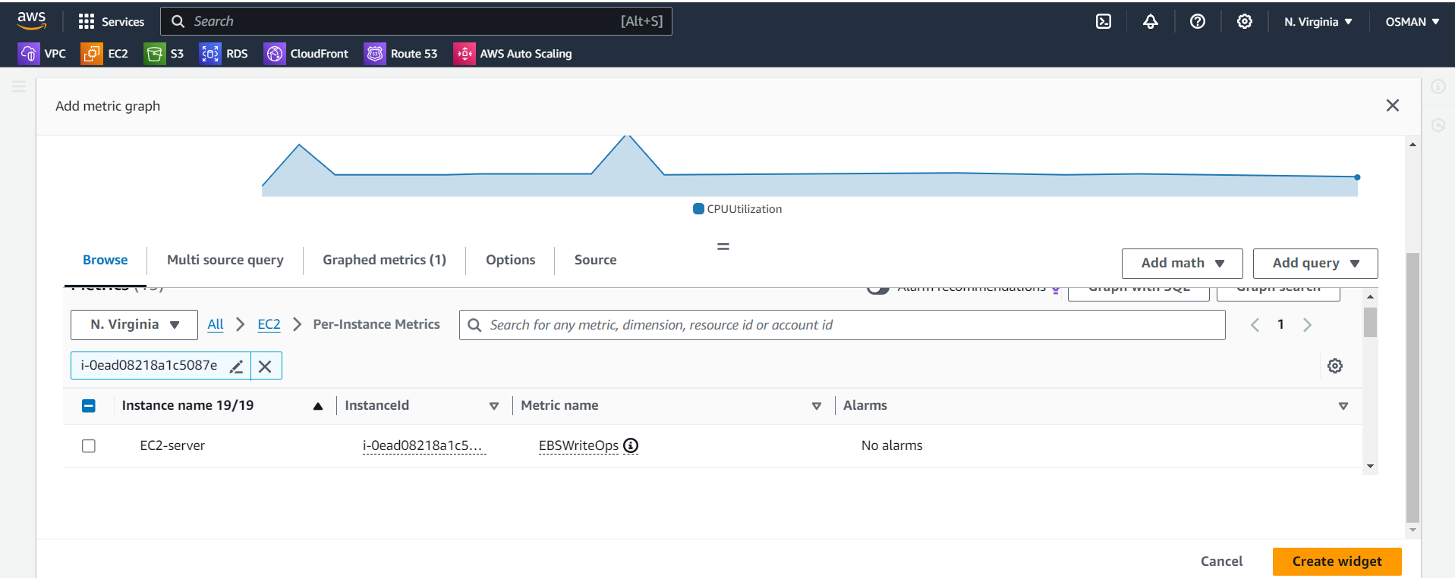

Here dashboard is created for Ec2 CPU utilization.

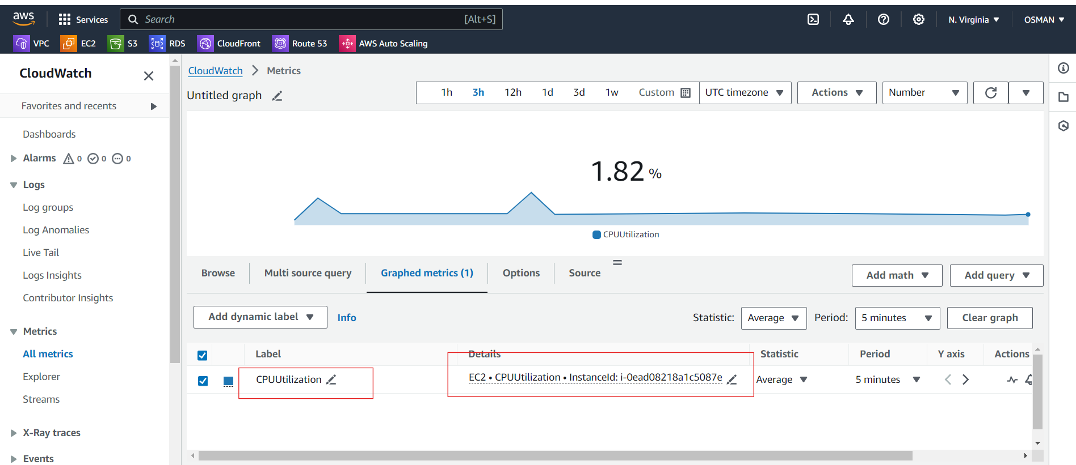

12) CPU utilizationis more than 70% then it should triggere Autoscaling and launch new instance.

**Prerequisites:**

* An EC2 instance template (Launch Template or Launch Configuration).
* An Auto Scaling Group.
* IAM roles for EC2 and Autoscaling with required permissions.

1st we need to create Launch Template.

To do that we have to go Launch template and click on create Launch Template.

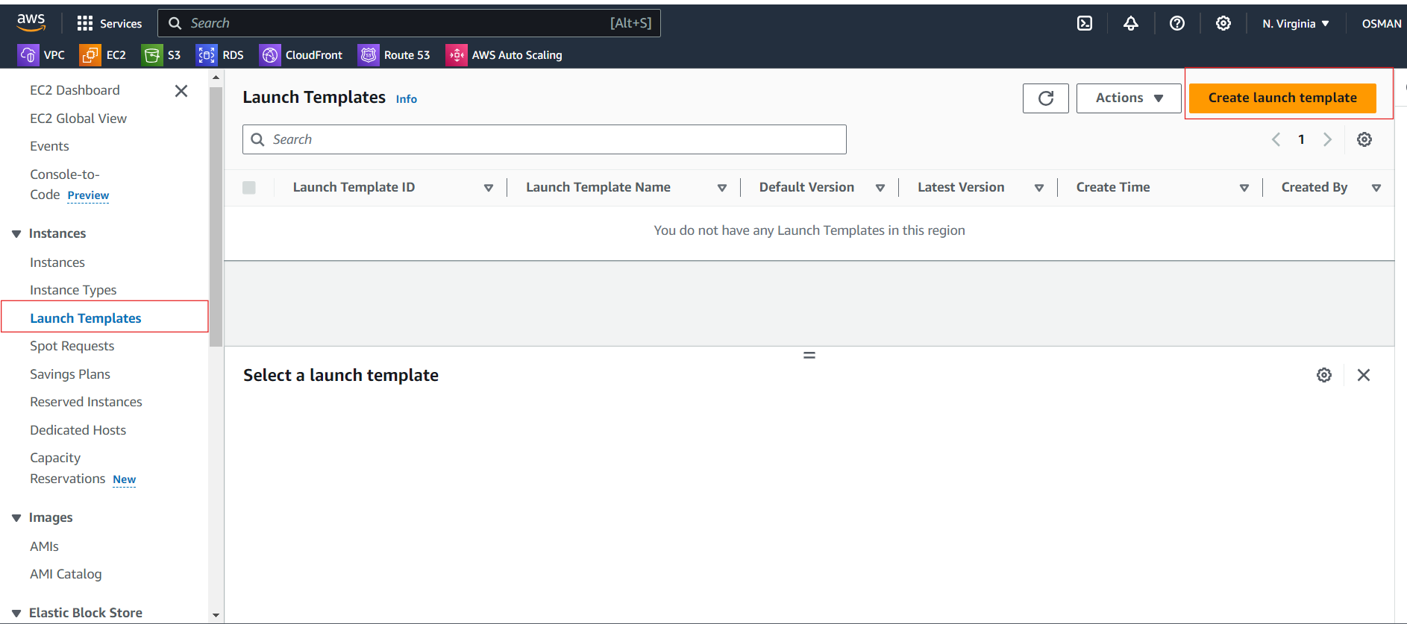

Give Template Name and version.

Tages--- if you want template tags to attach you can attach.

Source Template mean’s we are selecting the existing template.

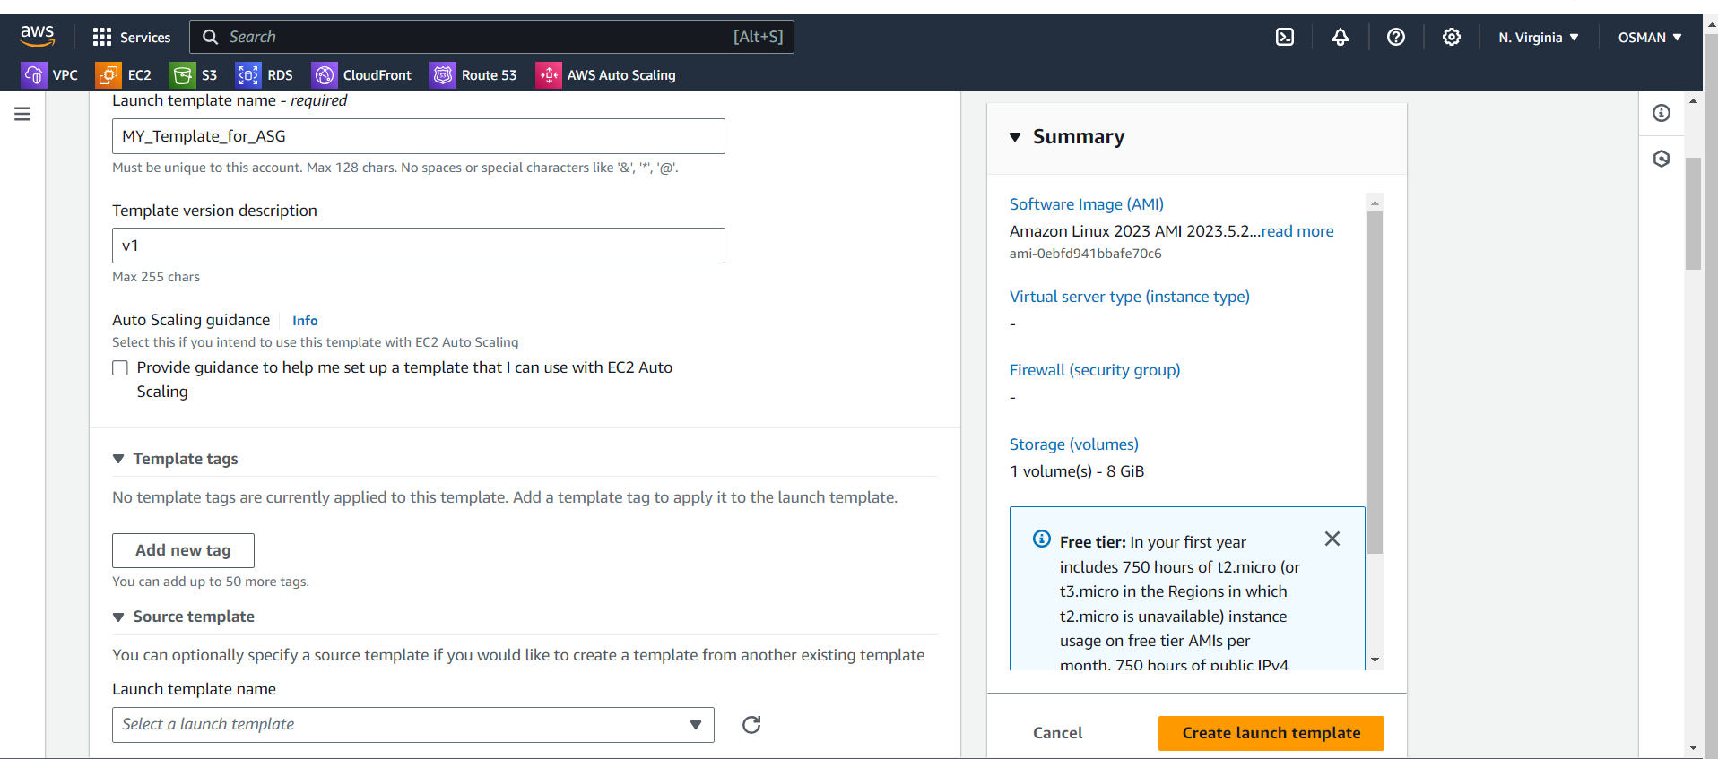

Just select AMI.

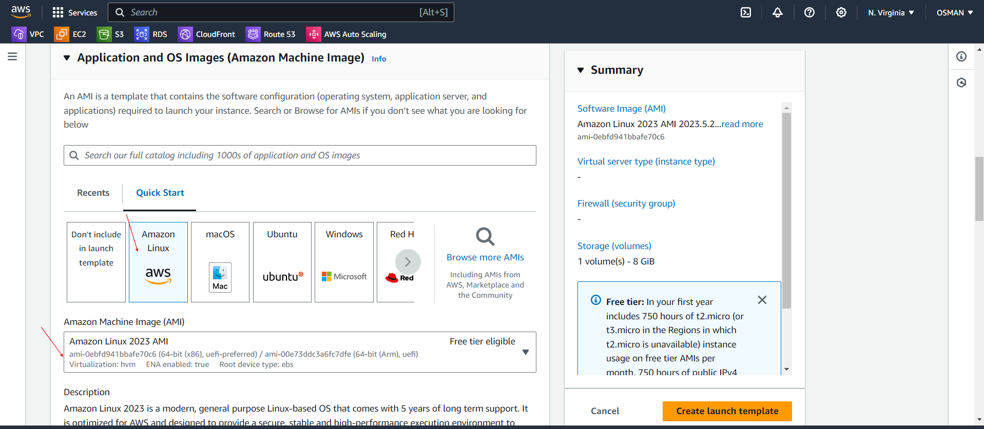

Select instance type and key pair.

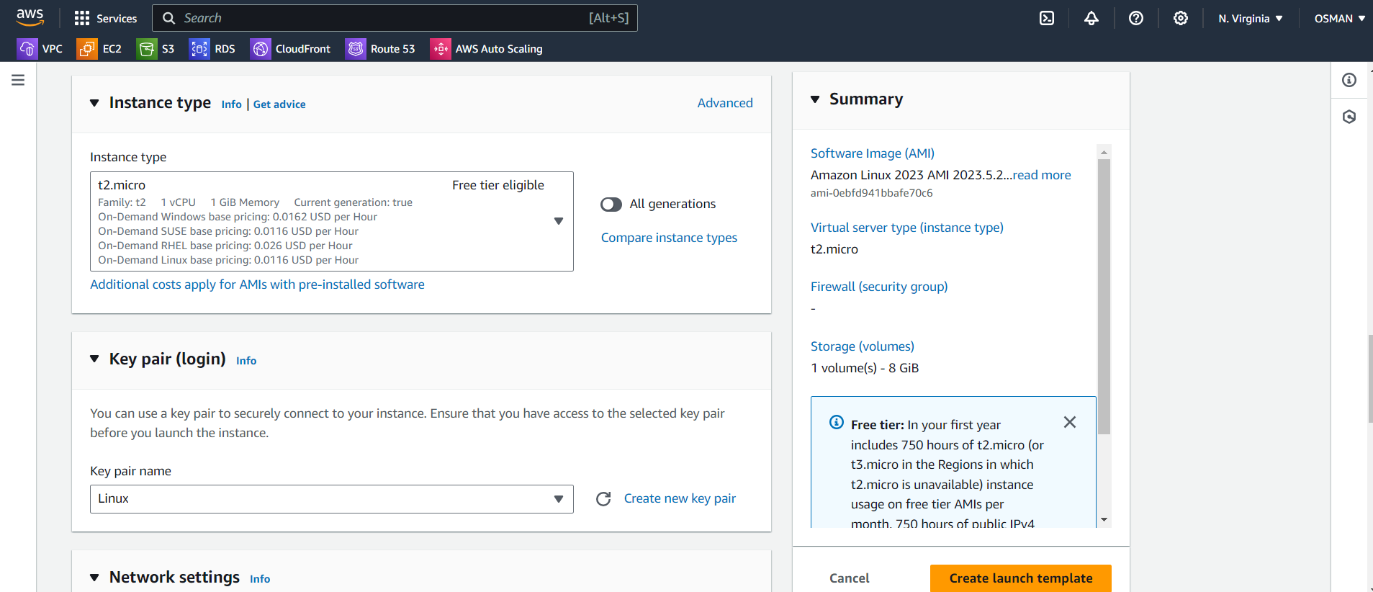

select subnet, security Groups and click on launch template.

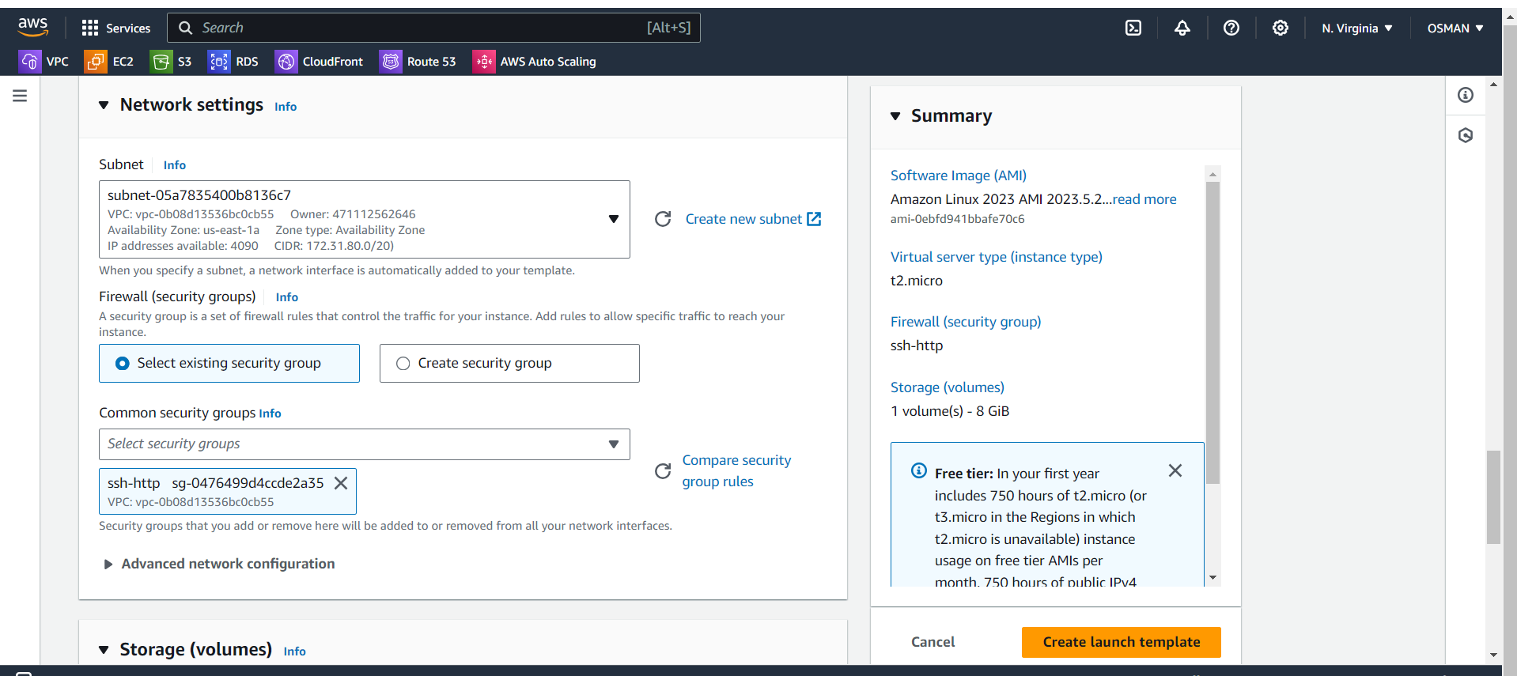

Our template is created.

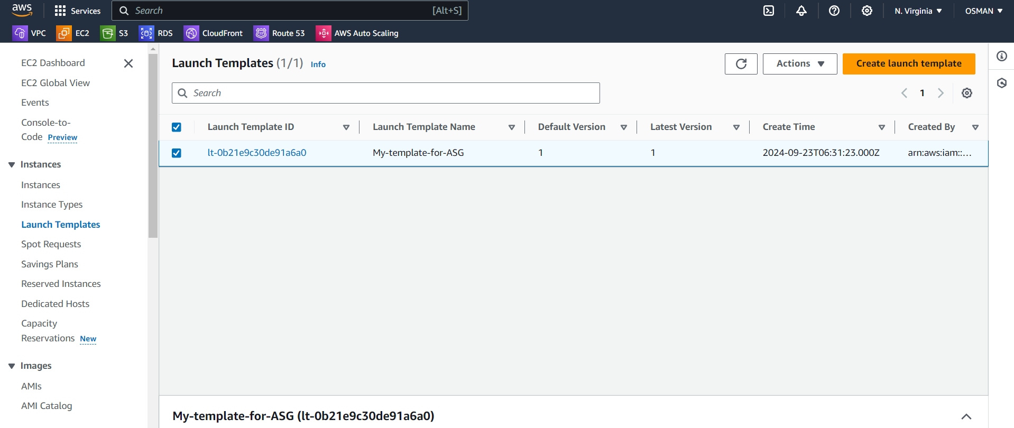

Go to auto scaling groups and click on create ASG.

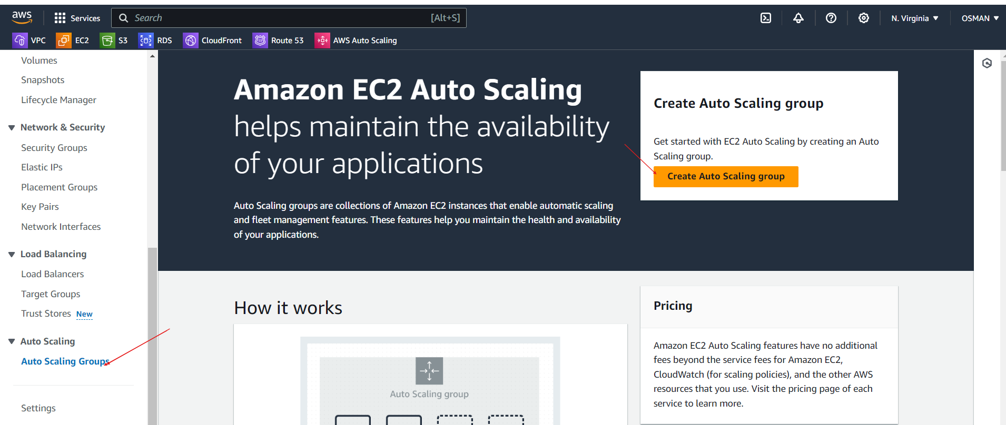

Give name and select template and click on next.

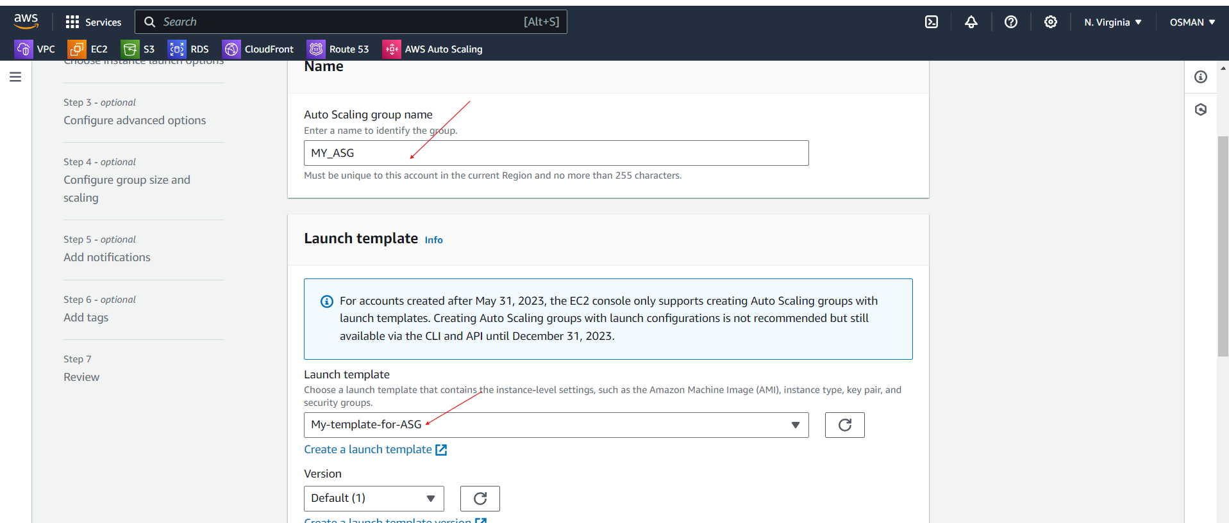

Select you VPC, Subnets, and click on Next.

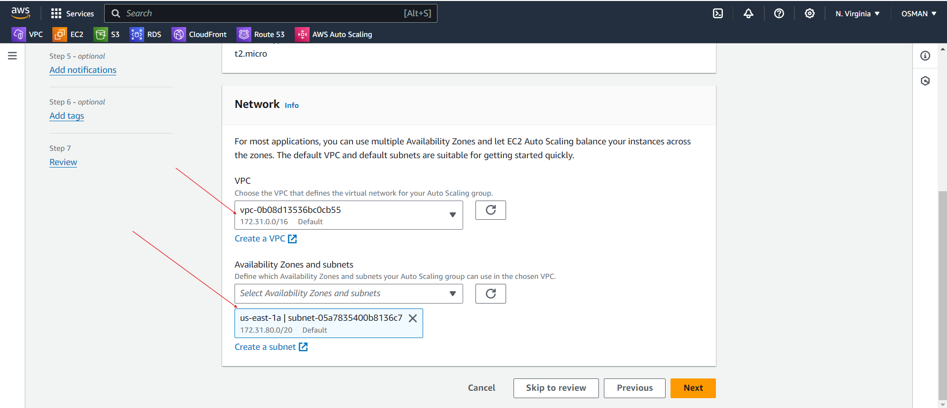

Health check grace period means through auto scaling groups create instance that status 2/2 check pass time.

And click on Next.

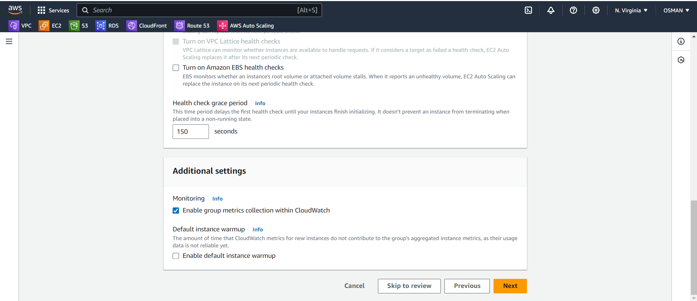

* Desired capacity means --- Your Auto Scaling group aims to keep **1 EC2 instance** running under normal conditions.
* Minimum Capacity: The minimum number of instances your Auto Scaling group will maintain, ensuring it never goes below this number (e.g., 1 instance at all times).
* Maximum Capacity: The maximum number of instances your Auto Scaling group can scale up to, preventing it from exceeding this limit (e.g., 2 instances at most).

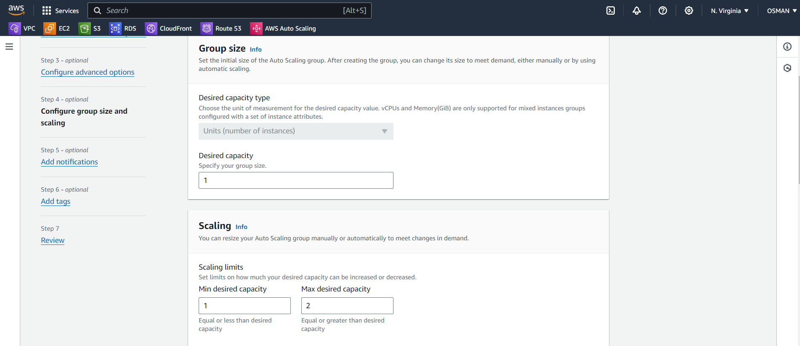

Here you need to select s

After that click on next.

Click on create ASG.

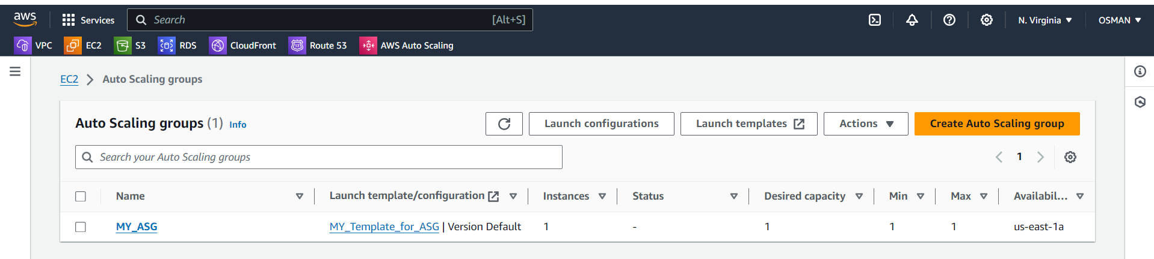

Your ASG is created.

Now go to the Cloudwatch Alarms and created Alarm.